<https://www.youtube.com/watch?v=fLw8SfvaJWA&list=PLwdnzlV3ogoXaceHrrFVZCJKbm_laSHcH&index=3>

<https://www.youtube.com/watch?v=E5jVBqe59EE>

# What is AI?









# What is required to solve any AI problem?



# Traditional Programming vs Programming with AI



# State Space Search





















This kind of paradigm of problem solving is called ‘State Space Search’. All possible configurations is called a State Space. All possible actions that you can take are called Rules/Operators. Here, you can move an empty tile to the right or left or up or down. Those are the rules.

You have to feed Start State, End State and Rules to solve a problem using State Space Search.

# Productions System (Rules System)



Productions means Rules.

Database means a set of Rules (database of rules).





Selecting rules and keeping track of the sequences of the rules that are already tried and should be tried is called Control Strategy.





<https://www.youtube.com/watch?v=Aebkfuqj1Og>



Production System helps in structuring AI programs in a way that facilitates describing and performing the Search Process.

It consists of 4 components

* Set of rules(productions are called rules)
* Knowledge Base/Database where these rules are stored. This is the core repository where all the rules and facts are stored. In AI, the knowledge base is critical as it contains the domain-specific information and the if-then rules that dictate how decisions are made or actions are taken.
* Control strategy – Control Strategy is a technique or strategy, tells us about which rule has to be applied next while searching for the solution of a problem within problem space. A good control strategy is always required to decide which rule need to be applied during the process of searching for a solution to a problem.
* Rule Applier – Based on control strategy, it applies the rules



Monotonic Production System – A monotonic production system is when two rules are simultaneously applied to the machine. Using one rule doesn't affect the other rule in any way, which makes their co-existence easy.

e.g. You have following rule in knowledge base

earth moves around the sun.

If you add another rule, ‘earth is round’. This new rule will not change the decision that took based on previous rules. So, all old rules still remain valid.

Non-Monotonic Production System – It’s reverse of Monotonic System.

e.g. you have following rules in knowledge base

birds can fly.

Now, you add new rules

Penguin is a bird.

Tweety is penguine.

Whatever decision you took based on first rule(birds can fly) will be changed based on newly added rules.

Partially Commutative Production System – application of different rules in different orders will you take you to the same state x to y.

Commutative Production System - Monotonic + Partially Commutative

<https://www.youtube.com/watch?v=ZEfQKo4dN4E>





Keep doing this until we arrived at goal state.





Uninformed vs Informed search

When you don’t know much about the problem, you have to keep applying random rules and at some point, you will reach to the goal state.

When you know the most about the problem, you can apply a correct sequence of problem that reduces the total cost of finding the goal state.

<https://www.youtube.com/watch?v=gZpUcsB9TFc>



# Computational Cost





In uninformed system, Rule Application Cost is very high because large number of rules have to be applied to find the solution. Control Strategy Cost is very low because we don’t have to determine the sequence of rules



For informed system, it is reverse.



Too much information can also increase the overall cost.



# Control Strategy

Control Strategy is a technique or strategy, tells us about which rule has to be applied next while searching for the solution of a problem within problem space. A good control strategy is always required to decide which rule need to be applied during the process of searching for a solution to a problem.

<https://www.slideshare.net/slideshow/control-strategies-in-ai-255661388/255661388#7>













An irrevocable control is a control strategy where, if a rule is applied once it cannot be retraced. Whereas a tentative control strategy is about applying a rule with a provision to retrace the application of the rule later.



# Forward and Backward Production System





# Commutative and Decomposable Product Systems



Commutative Production System: Rules can be applied in any order. They will take you to same goal state. Monotonic + Partially Commutative = Commutative

<https://www.youtube.com/watch?v=ZEfQKo4dN4E>



Monotonic - You applied R1 on S0 and got S1. R1 is still valid at this stage and can be applied to S1.

Partially Commutative – any combination of R1, R2 and R3 can take you to SG.





Some path may lead to termination, but some other path may not lead to termination.













Instead of considering C,B,Z as one problem, we can decompose0 it into three problems – C B Z

# Optimal and Complete?

An **optimal algorithm** is a method that finds the best solution to a problem, while minimizing resource usage and ensuring the best performance (**lowest cost to reach the goal state**). The goal is to find a solution that maximizes or minimizes a given objective function. For example, an optimal solution might be the most profit or the least cost.

A **complete search algorithm** is a problem-solving technique that systematically explores every possible solution to find the best one. It's also known as brute-force search. **It always reaches to the goal.**

A complete search algorithm is guaranteed to find the best solution if it exists, but it can lead to higher computational costs. To perform a complete search, you need to be able to generate each combination and perform backtracking.

Complete search is foundational to understanding depth-first search, which is used to search through tree or graph structures.

This involves trying out every possibility and testing them. Although brute-force search may feel wrong, sometimes the most straightforward solution is the best one. To perform a "complete search" we will need the ability to generate each combination and the ability to perform backtracking.

# Uninformed Search



## Review of Problem Solving as Space











This can be visualized as a Graph. Where I am looking for some path that takes from Start node to Goal node.





Vertices that share the same Edge are called adjacent vertices.

Edges that share the same Vertex are called adjacent edges.



Length of the path from start to end node is a number of edges (not number of vertices).





Directed Graph where edges are directed from one vertex to another.







Here, we are talking about a graph where each node (vertex) can have lot of data along with state information.

Each edge (arc) is an instance of the operator (rule).



Look at ShortestDistanceBetweenTwoCellsInMatrixOrGrid.java





It is not practical to represent all the possible states is the space. We start from the Start Node and keep creating Successor nodes till we find a Goal node.





Branching factor (b) = maximum number of successors of any state

Depth (d) = shortest distance between start and end goal

Maximum depth (m) = maximum possible length of the entire State Space.

## Graph Search Procedure (BFS/DFS)





## Uninformed vs informed Search



### Uninformed Search Strategies



#### Breadth-First Search (BFS)



<https://www.geeksforgeeks.org/breadth-first-search-or-bfs-for-a-graph/>

In BFS, you have to use Queue.









It is optimal because we will find the goal node at shallowest possible level in the graph.

#### Depth-First Search (DFS)



<https://www.geeksforgeeks.org/depth-first-search-or-dfs-for-a-graph/>

In DFS, you have to use Stack. So, you put successor nodes on the top of the Stack and remove from the top.





DFS is not complete. What if it is infinite depth spaces. You keep going down and you do not the find the goal node.

It is not an optimal search strategy because you can keep going down in the graph and the goal state might present on another branch.

#### Depth-Limited Search



What if the goal node is just after the depth L!!! You will never find the goal node.

#### Iterative Deepening Search



Iteratively, increase L.







#### Uniform-Cost Search



In BFS, whoever node costs the smallest, expand that node first.



UCS is optimal because it always chooses the path with the lowest total cost from the initial node. Since any cheaper solution would have already been found, UCS is guaranteed to find the optimal solution.

#### Example

We use Queue as OPEN list



We use Stack as OPEN list



#### Bi-directional Search





#### Disadvantages

If there is a cycle in a graph, you may generate the same states (visit nodes) infinite number of times.So, linear problem can turn into an exponential one.





# Heuristic Search

<https://www.youtube.com/watch?v=0awSpFyh2MY&list=PLwdnzlV3ogoXaceHrrFVZCJKbm_laSHcH&index=8>

<https://www.youtube.com/watch?v=5F9YzkpnaRw>

## Introduction

Problem domain information is called heuristics.





Heuristic is a Greek word which means find or discover. It is usually the study of method and rules of discovery an invention.

Pruning means trimming.

## Heuristic Function









Unlike to BFS, where we keep creating successor nodes as it comes, we follow a specific path to the goal node using Heuristic Function.



### Problem Relaxation and Admissible Heuristic









The cost of a solution is then the number of actions taken and we want to find the cheapest solution.











If the solution is the minimum cost solution then it is optimal. As inadmissible heuristic overestimates the cost, it breaks the optimality.



Heuristic is nothing but the estimated cost to reach to the goal state.

Node C’s heuristic h(n)=2 is lower than Node B’s heuristic h(n)=4.

As Node C’s heuristic estimate is lower than that of Node B, we will choose the path from C to Goal state instead of from B to Goal state.

But in reality, cost of going from C to Goal state is more(3) than that of going from B to Goal state(2).

Why this happened?

This happened because heuristic overestimated the cost. It was an inadmissible heuristic. It broke optimality (it does not lead to a path which is the minimum).

### Dominance



### Composite Heuristic



Composite heuristics are algorithms that combine two or more heuristics to improve the worst-case scenario.

### Consistent Heuristic





<https://en.wikipedia.org/wiki/Consistent_heuristic>







# Informed Search Strategies

<https://www.youtube.com/watch?v=-Rf2hOyjZB8&list=PLwdnzlV3ogoXaceHrrFVZCJKbm_laSHcH&index=7>

Informed search depends on task-dependent information and are also called heuristic search.











e.g. in 8-puzzle problem, we used an evaluation function that is Misplaced tiles and Manhattan search

## Best-First Search



Best-first search is a combination of DFS and BFS. Start with DFS and switch the branch whenever some competing path looks more promising.





Expand A to B, C, D

Heuristic value of B is 3

Heuristic value of C is 5

Heuristic value of D is 1

Because the heuristic value of D is the least one, we will expand D

Heuristic value of E is 4

Heuristic value of F is 6

Now, instead of going down using DFS, check the heuristic values of unexpanded nodes. B has the least heuristic value. So, instead of expanding E, expand B.



Now E has the least heuristic value. So, search will jump back to E.





Every time, we put new successor nodes in OPEN list, we reorder this list based on heuristic values of those nodes.

### Algorithm A and A*









Graph search algorithm using this evaluation function for ordering nodes is called Algorithm A.







Heuristic value is an estimation cost. N is some node in between start and goal node.

**A* is an admissible algorithm that guarantees and optimal solution.**



h(n) is calculated based on number of misplaced tiles. For start node, g(n)=0 and h(n)=3. There are total 3 misplaced tiles.

f(n) for start node = g(n)+h(n) = 0+3 = 3





**If h(n)=0 and g(n)=1 for all nodes then, we would end up having BFS.**

Watch these videos for sure.

A* algorithm – <https://www.youtube.com/watch?v=tvAh0JZF2YE>

A* admissible (benefits of underestimation) - <https://www.youtube.com/watch?v=xz1Nq6cZejI>

**You will get optimal result only when you underestimate h(n). h*(n) is the actual cost to go from state n to goal state g. h(n) is the estimated cost to go from state n to goal state g.**

**If h(n) <= h*(n), you will be able to find the optimal path to go from start state S to goal state G.**





Time and space complexities



A* gives optimal solution, if h(n) <= h*(n) ----- if h(n) is underestimated.







## Local Search Algorithms



e.g. Hill Climbing algorithm



### Hill Climbing Search

Watch <https://www.youtube.com/watch?v=3SiWtAnUROs>



It is a local search algorithm. It doesn’t have knowledge of global domain.

It’s a greedy algorithm.

It doesn’t remember the previous states in state space.

It doesn’t backtrack.

When you keep doing state space search, you keep expanding the search till you are getting a state having better heuristic than current state. E.g. current state has heuristic 5, when you expanded current state into three new states and they have heuristics 4,5,6, then you found a new state with better heuristic 4 then current state’s heuristic 5. So, you expand the state that has heuristic 4.

Once you expand the state, you forget old states. No backtracking. You will never visit the old nodes(states) again in future.

Problems with Hill Climbing

* Local maximum – you keep climbing the hill till you get the peak of current hill. You will never come to know that there is a better hill after current hill.





In another video , we have chosen the ‘value(next) < value(current).

Here, it takes the value(next)>value(current). It depends on our heuristics.



If you look at the chosen path, we are choosing the states with decreasing heuristic values.





If you start climbing the hill in wrong direction, you may reach to local maximum instead of global maximum. This is a very serious problem with Hill Climbing algorithm.



### Simulated Annealing (Stochastic Hill Climbing)









Stochastic hill climbing is a local search algorithm that uses randomness to optimize functions. It's a variation of the basic hill climbing method, which always chooses the steepest uphill move. Stochastic hill climbing, however, chooses a random uphill move, with the probability of selection based on the steepness of the move.

**How it helps**

The random element in stochastic hill climbing helps to avoid getting stuck in local maxima. However, it doesn't guarantee a better solution.













# Constraint Satisfaction Problems (CSP)

## Introduction to CSP

Uninformed and Informed search algorithms use State Space Search methodology. CSP (Constraint Satisfaction Problem) uses constraints (rules). It uses intelligent backtracking methodology. DFS also uses backtracking, but it is not intelligent.

<https://www.youtube.com/watch?v=AgyCSmDVk5s>

Intelligent backtracking in CSP.

<https://www.youtube.com/watch?v=udOfKqeLVSg&t=10s>

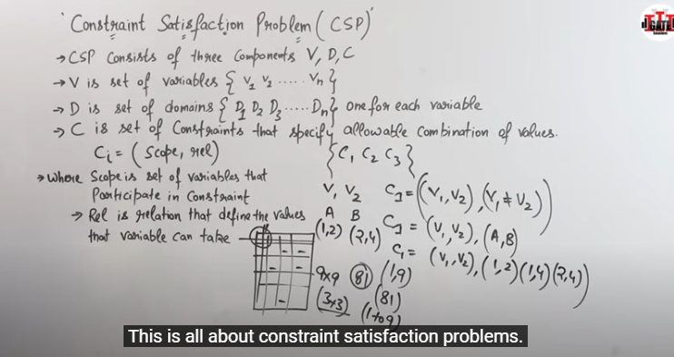

CSP (Constraint Satisfaction Problem) is made of V, D and C – Variables, domains for variables and constraints (Rules).

Each constraint is made of variables and the relationship between those variables. E.g. here, I have created a c1 constraint that says that this constraint can take two variables and the domains (values) of those two variables should not be equal. Values are taken from domains to which those variables belong to.

In Sudoku problem, you have total 81 variables (squares) where you can enter the numbers. Constraint is there should not be a duplicate number in any column or row.

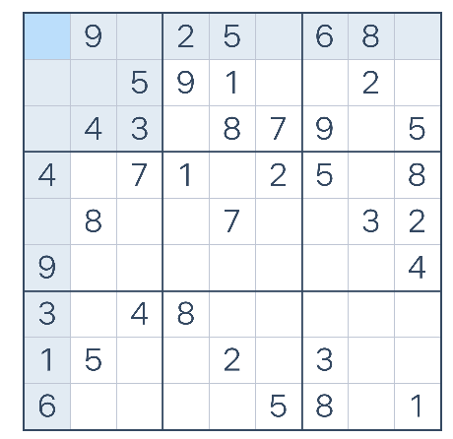

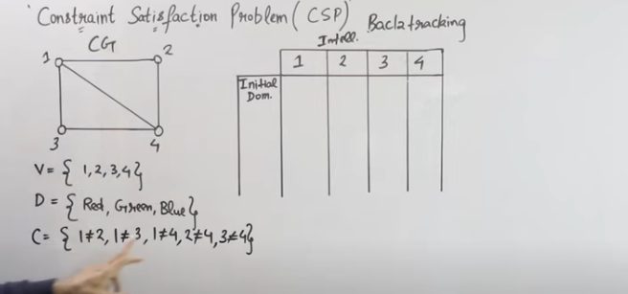

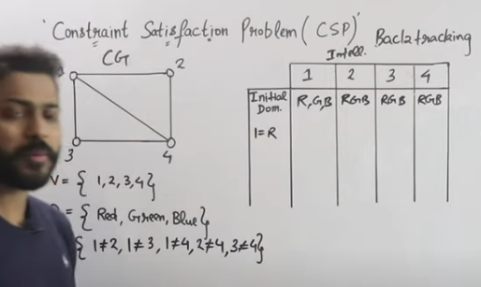

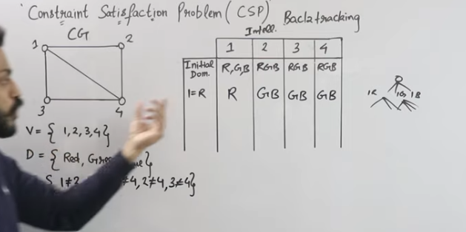

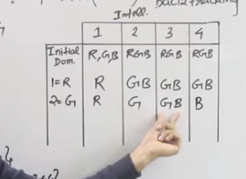

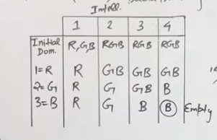

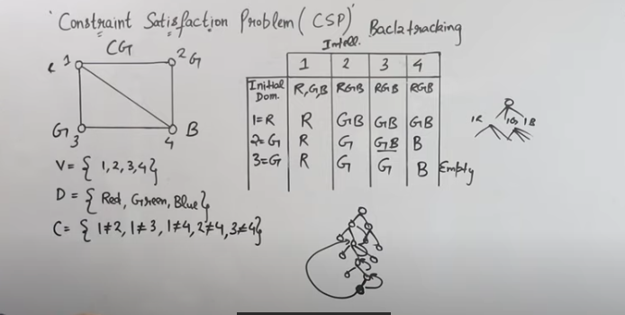

**CSP is a specialized form of DFS**. DFS and CSP, both are based on Backtracking. DFS has brute-force type of backtracking. If you do not find a goal node(solution) at the deepest level of the tree, then you backtrack and go one level up in a tree to find the goal node.

In CSP, you directly backtrack to a node which caused a problem.

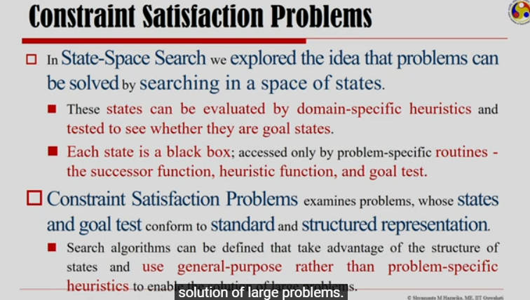

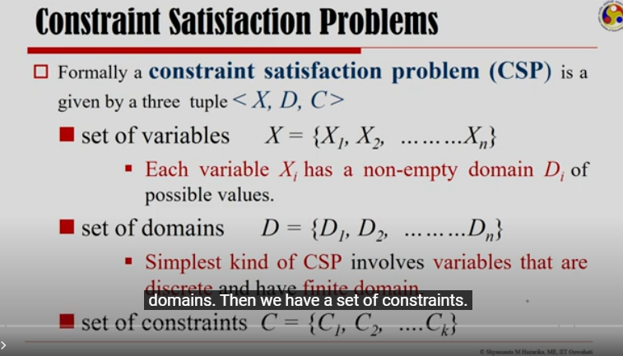

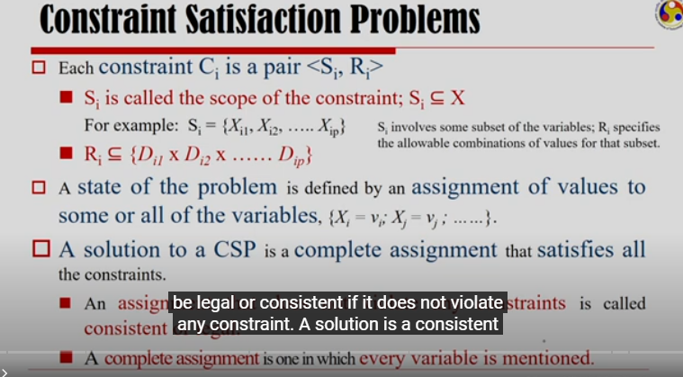

### N-Queen Problem

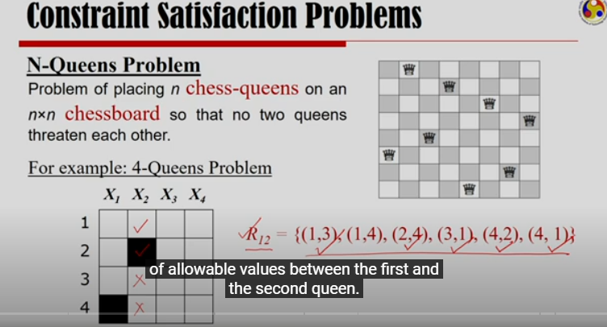

First and second queen can have R12 constraints. If 1st queen (X1) is put in row#1, then the second queen (x2) can be put in row# 3 or 4. If x1 is put in row#2, then x2 can be put in row# 4 only. And so on…

Just like that you can create the constraints R13, R14, R23, R24, R34

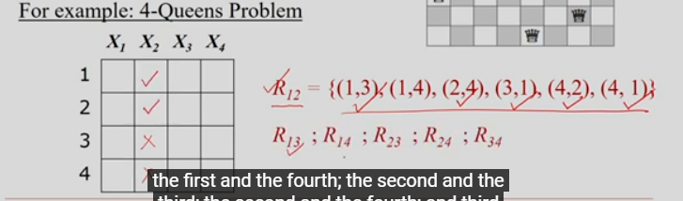

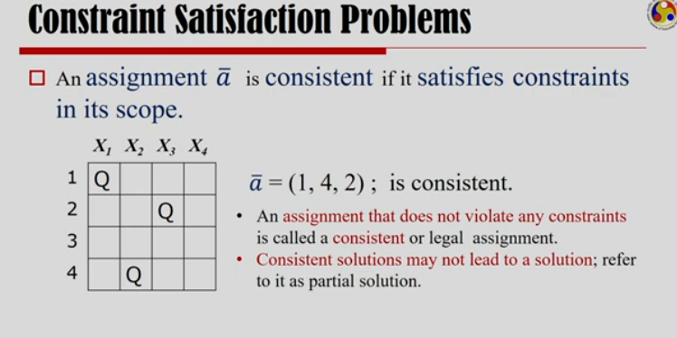

Assignment that does not violate any constraints is called a consistent or legal assignment.

We are not able to assign a place to 4th queen. So, consistent solutions may not lead to a final solution.

### Map-coloring problem

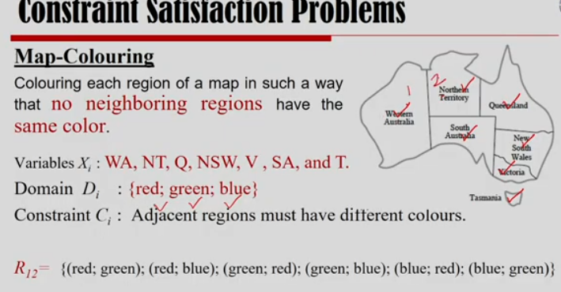

Following is the solution where we want to reach.

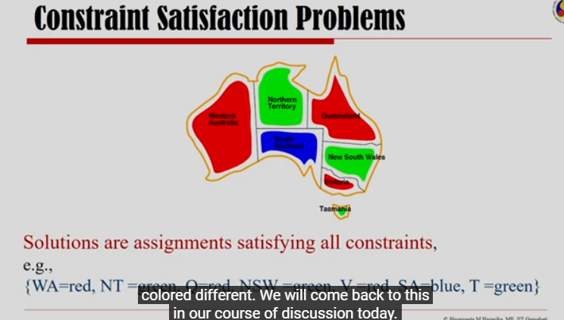

### Varieties of CSP

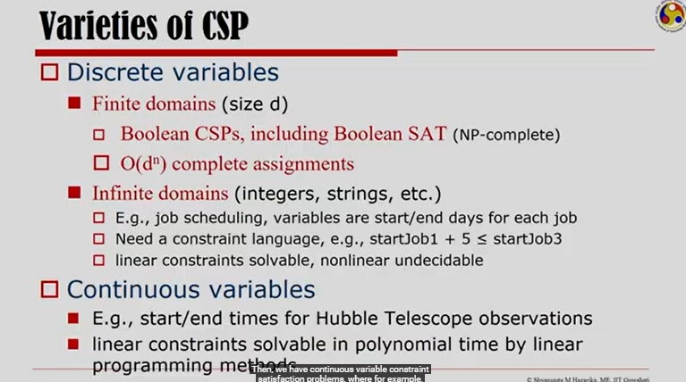

CSP means constraint satisfaction problem.

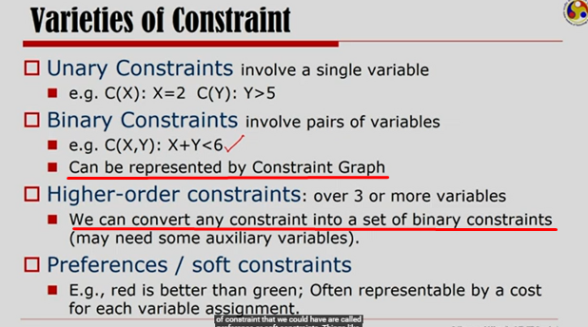

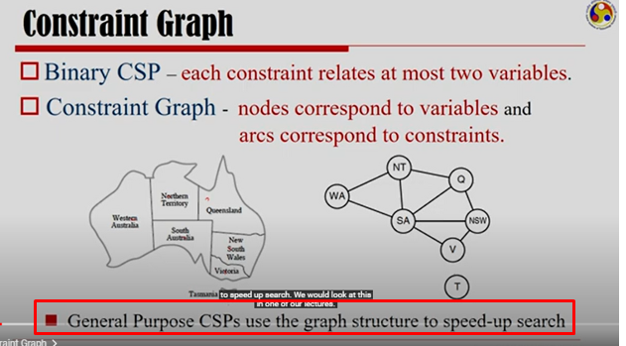

Not able to understand Cryptarithmetic Puzzle.

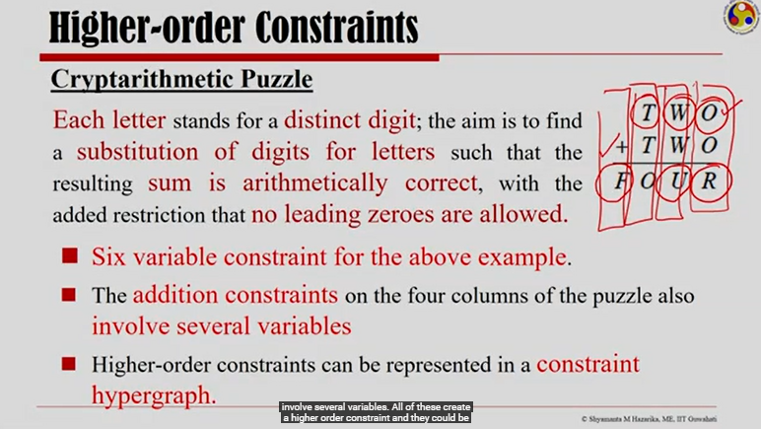

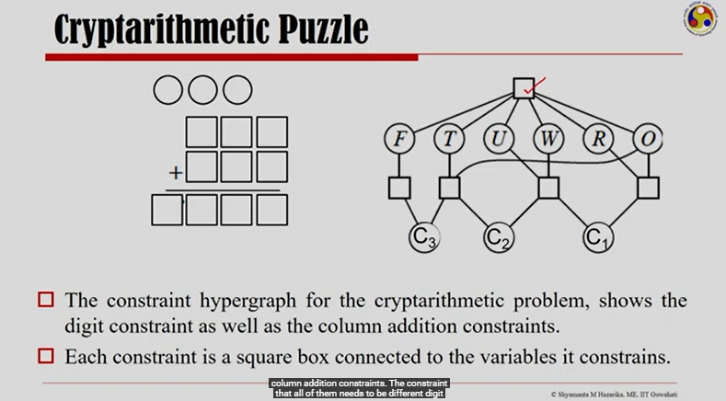

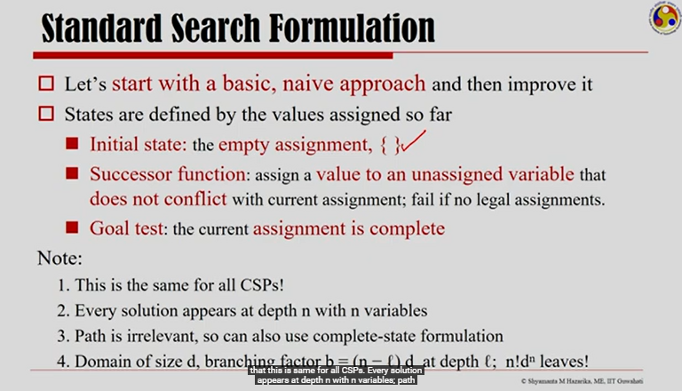

## Backtracking Search

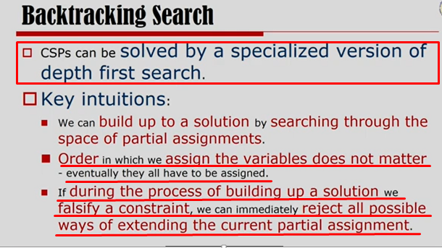

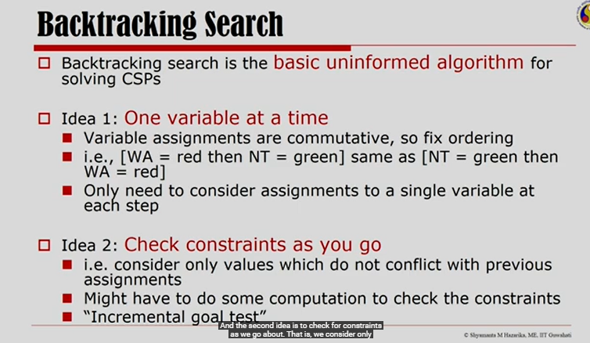

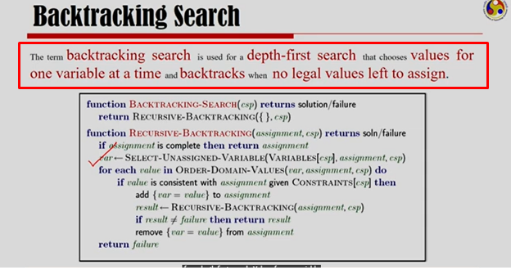

### Backtracking in 4-queen problem

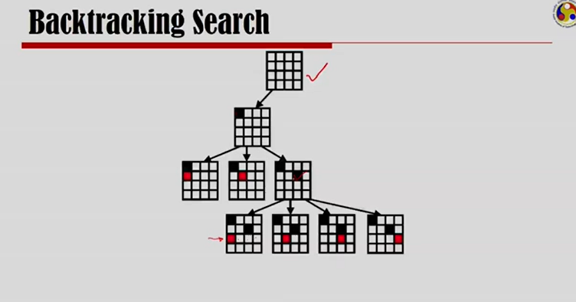

After assigning a second queen, there is no legal position left for 3rd queen, so we have to backtrack.

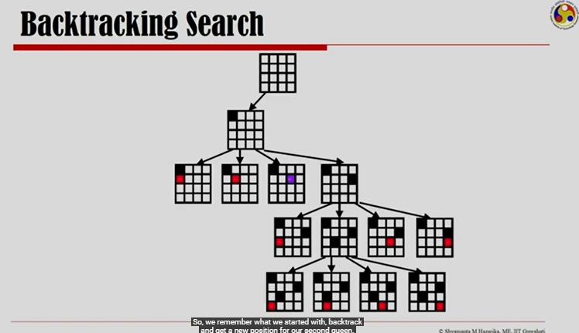

Backtrack and get a new position for a 2nd queen. And try to place 3rd queen and then 4th queen.

You will realize that you can not place the 4th queen. So, backtrack to 3rd queen.

3rd queen can’t be placed in any other position, so back track to 2nd queen.

2nd queen’s all positions are explored, so backtrack to 1st queen.

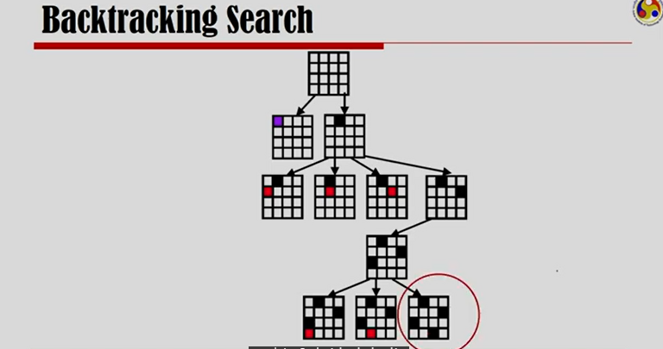

This is a plain backtracking like DFS. It is not an intelligent backtracking. Plain backtracking is not so effective for the large problems.

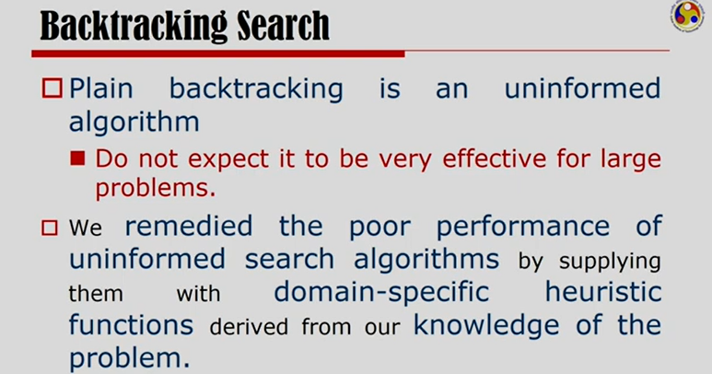

### Improving backtracking

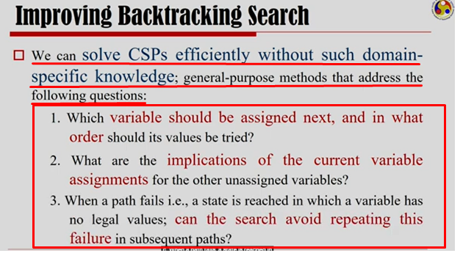

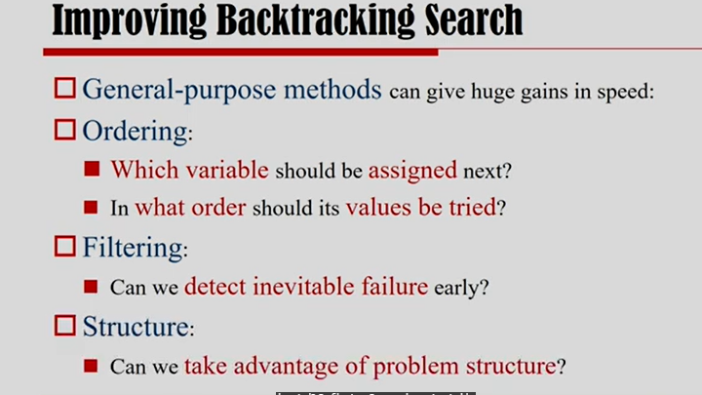

In order to achieve these benefits, we can use MRV (Minim remaining values) heuristic OR Degree heuristic.

#### Minimum Remaining Value (MRV) Heuristic

Choose the most constrained variable. Most constrained means the variable that has the least amount of values remained to choose.

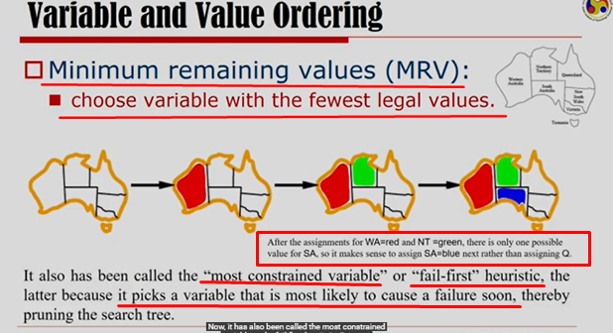

#### Degree Heuristic

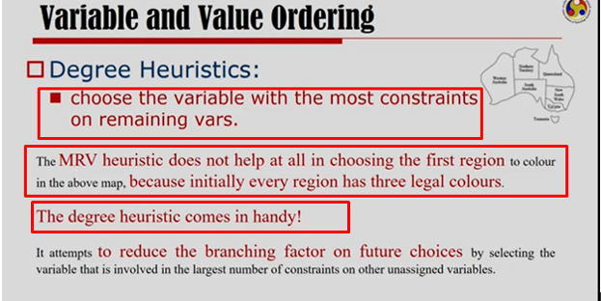

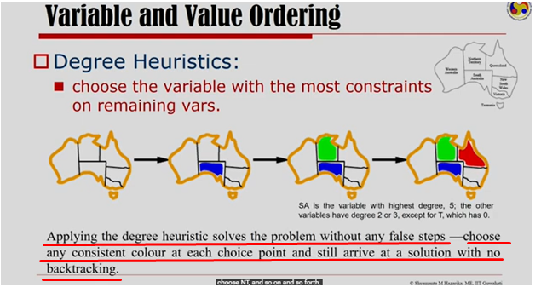

SA is the variable that can affect highest number of other variables. If SA is colored, then it will put constraints on all other connecting states to choose their colors. Choosing SA kind of variable first is called Degree Heuristic.

#### Least Constraining Value Heuristic

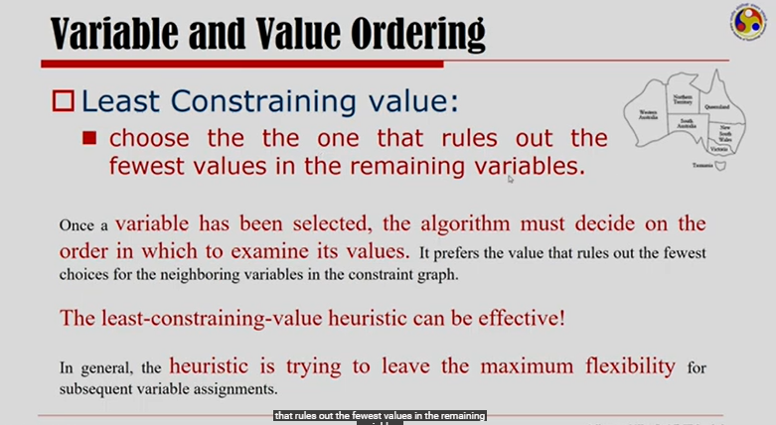

Choose the value for current variable in such a way that it is the least constraining value for the next variable. Choosing blue for Q state will eliminate all values for Q’s neighbor SA. The least constraining value heuristic should be red for Q state instead of blue.

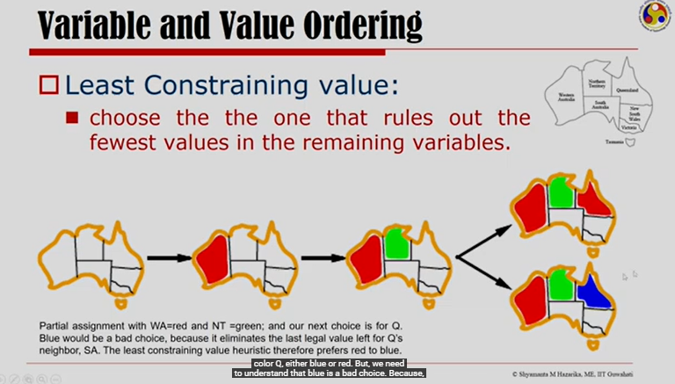

#### Propagating Constraints

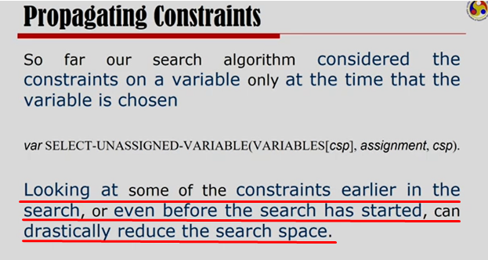

##### Forward Checking

When you are starting, states can have any color as legal value.

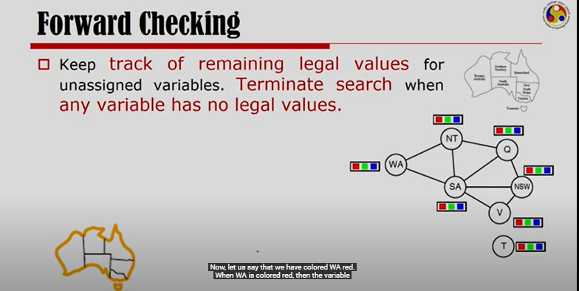

If we color WA=red, then only possible values for NT and SA are green and blue.

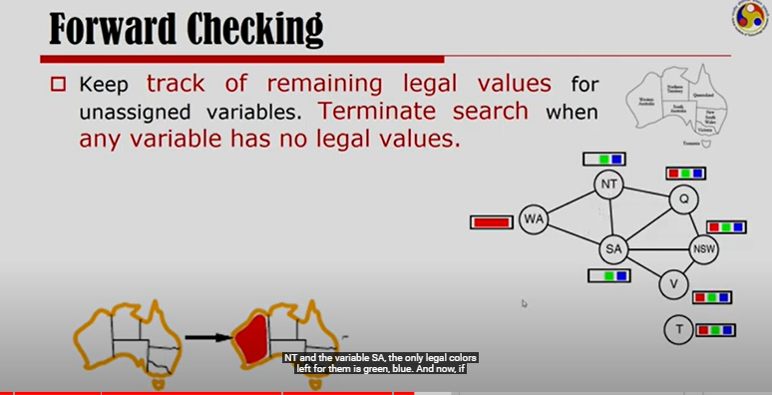

Now, if we choose Q as green, then only legal values for NT and SA is blue. Legal value for NSW is red or blue.

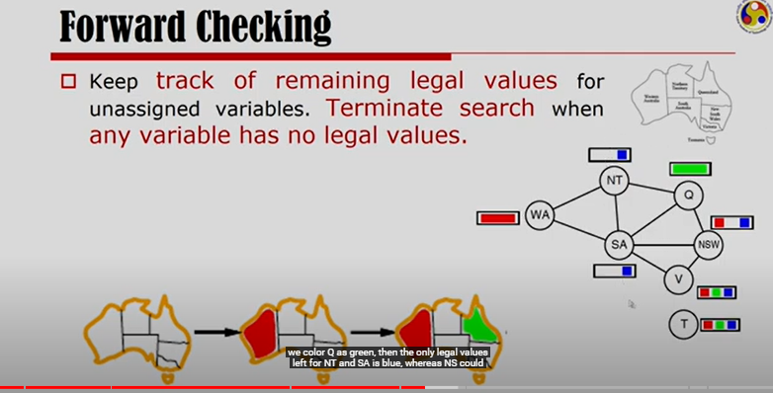

After we assign V = blue, no legal value will be available for SA. So, search will terminate there.

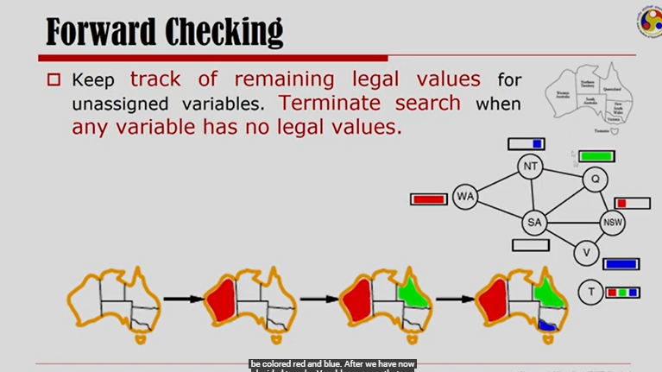

Forward checking is helpful, but it doesn’t provide early detection of the failure as we saw.

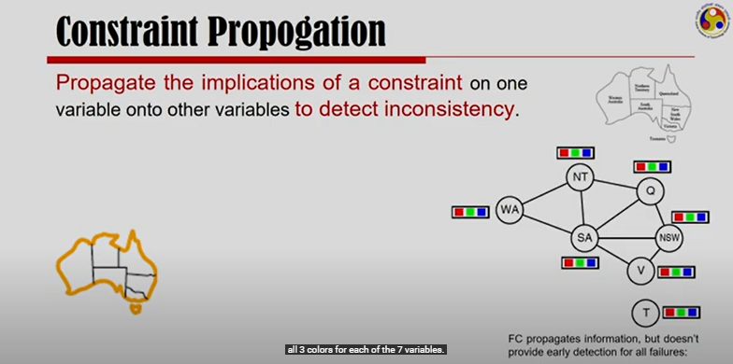

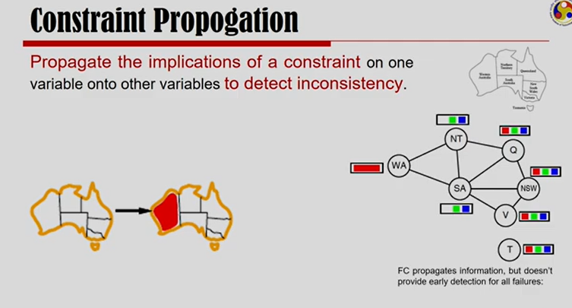

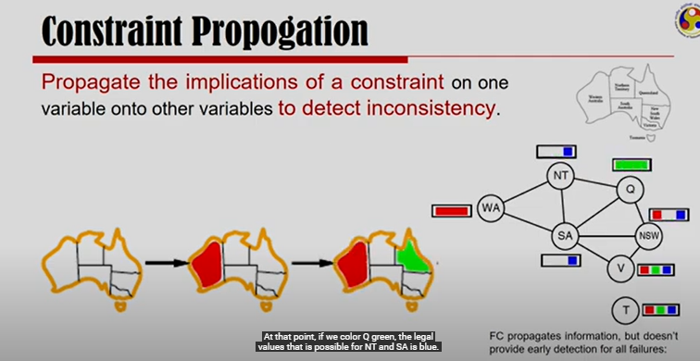

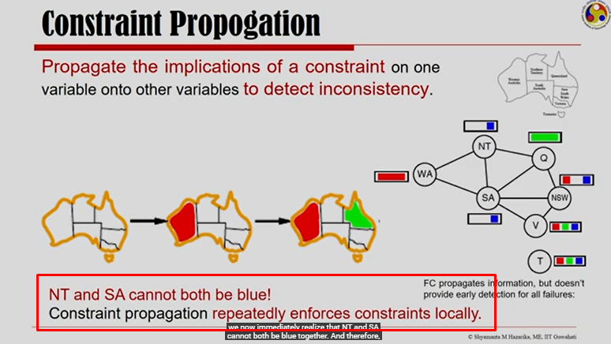

This is the early detection of failure.

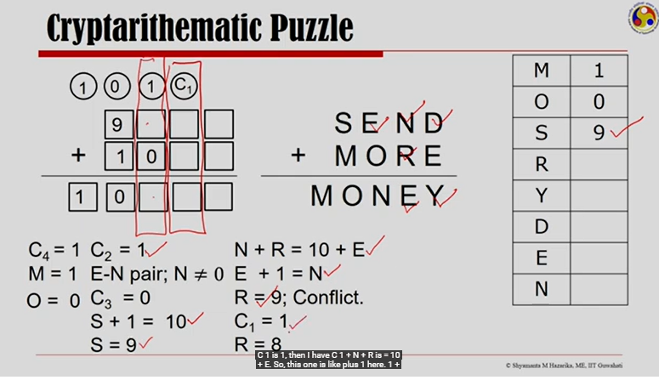

Cryptarithematic Puzzle is very complex. I am not able to understand it. It is a process of converting letters to numbers. I could understand N-Queen and Map-Coloring very well.

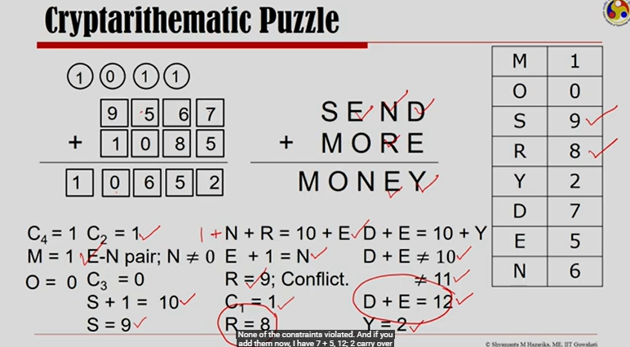

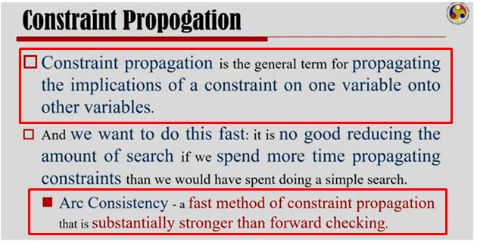

Arc Consistency is faster than Forward Checking method for Constraint Propogation.

##### Arc Consistency

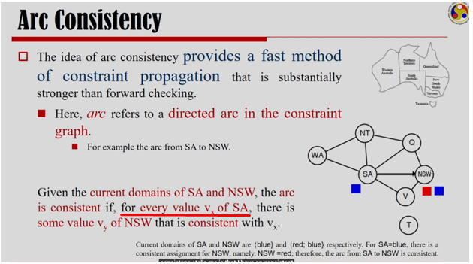

e.g. possible values(colors) for SA is blue and NSW is red and blue.

For SA(blue), there is a possible value red for NSW. But the same is not true from NSW to SA.

If you color NSW red, SA can have blue color, but if you color NSW blue, there SA can’t any color from available colors.

So, it is good to have a directed arc from SA to NSW. It means you color SA first and then NSW.

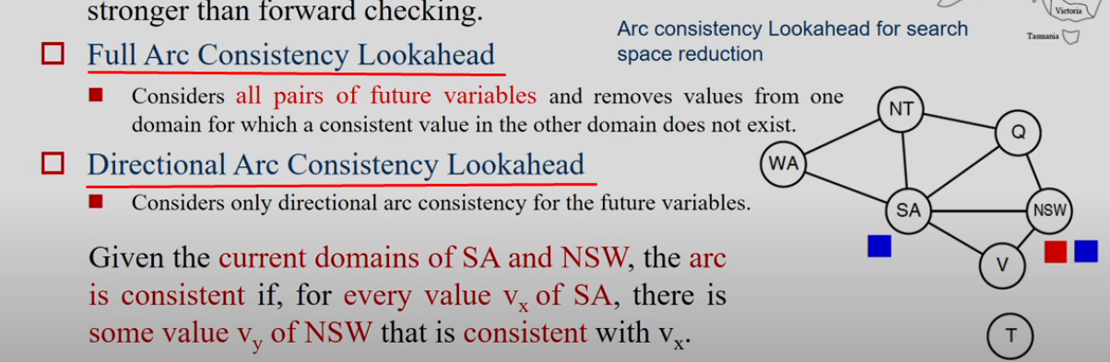

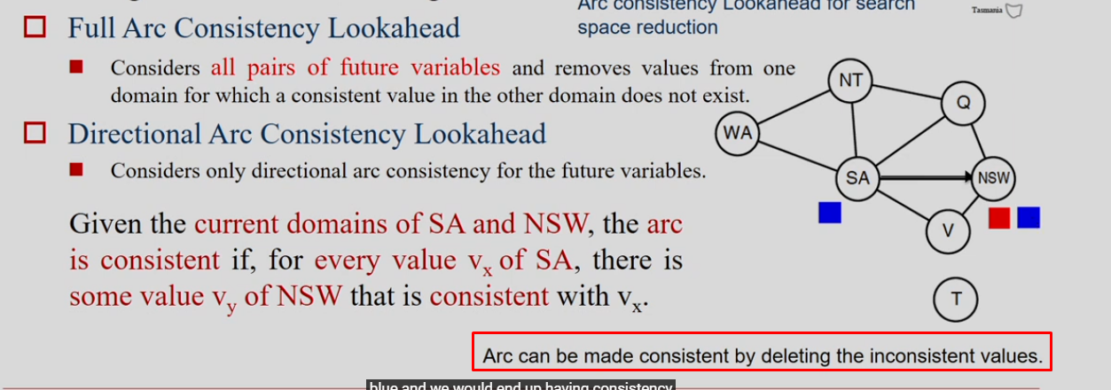

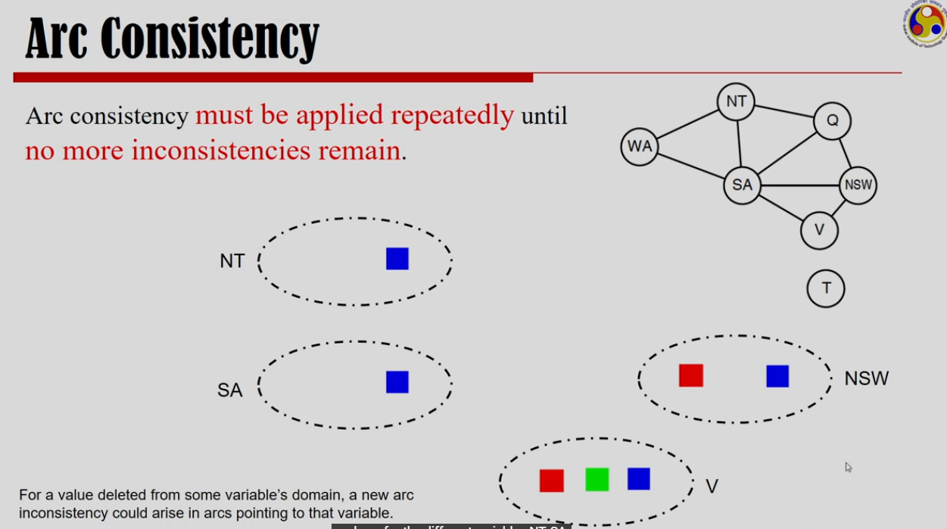

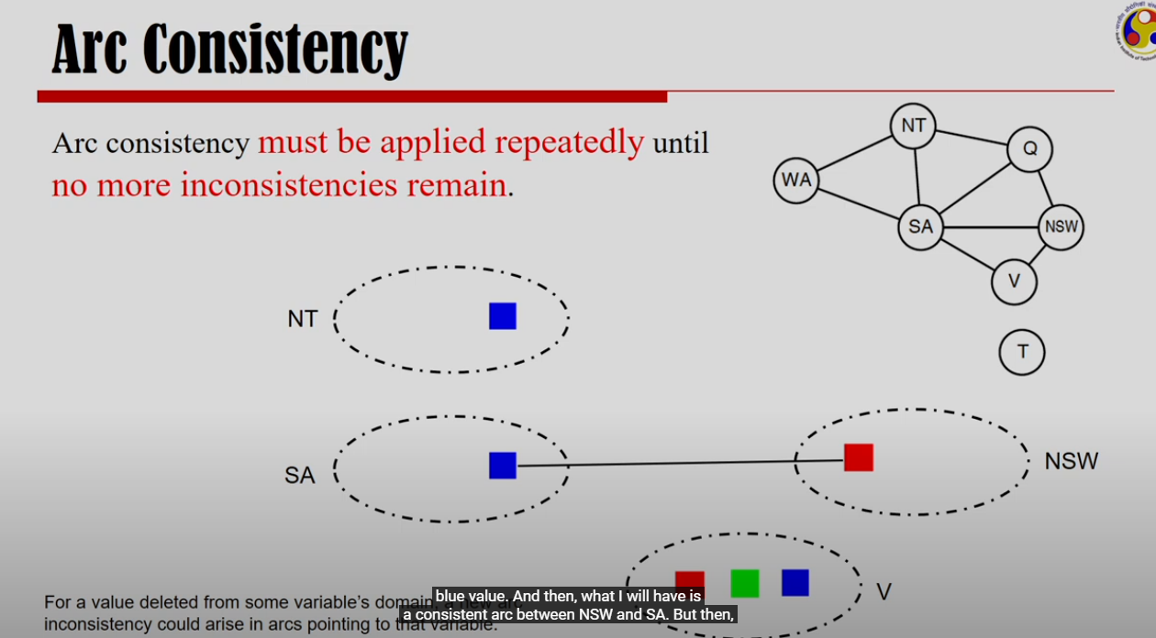

I can delete blue from NSW and then I can have a consistent arc from SA to NSW.

Now, to maintain arc consistency from NSW to V, I have to delete red from V.

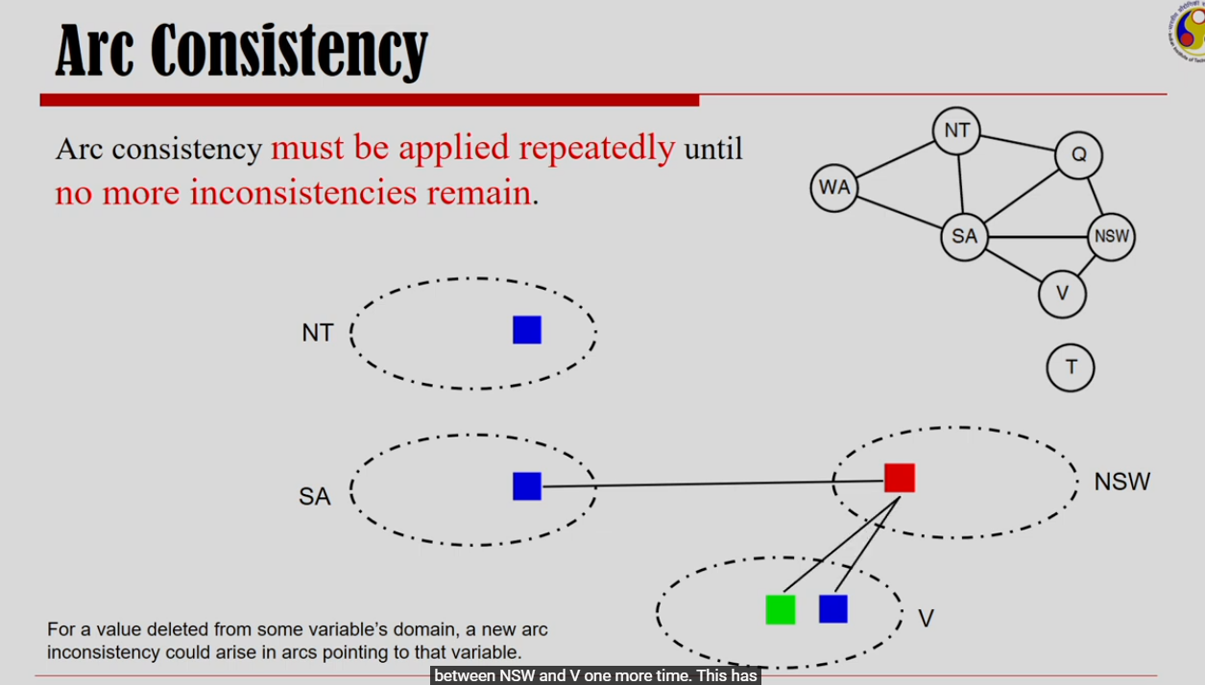

This kind of activity has to be done repeatedly until I no more have inconstancies.

If I want to create an arc consistency between NT and SA, then I have to delete blue from NT. But it will make the domain of NT empty. This is how arc consistency can detect failures earlier than forward checking.

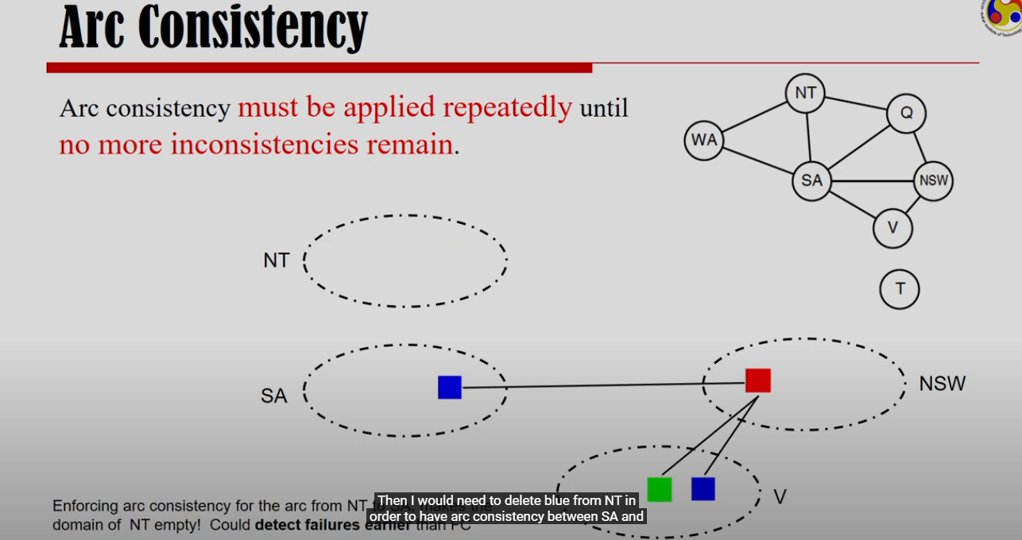

## Backtracking Strategies

### Chronological Backtracking

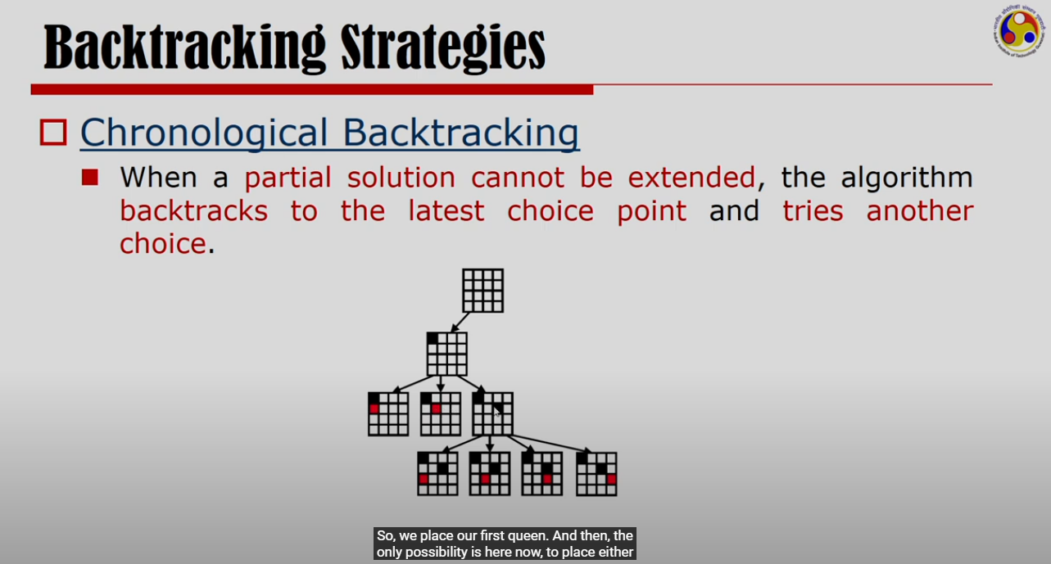

This strategy is same as what we already discussed before.

Backtracking to last choice point that is not yet exhausted.

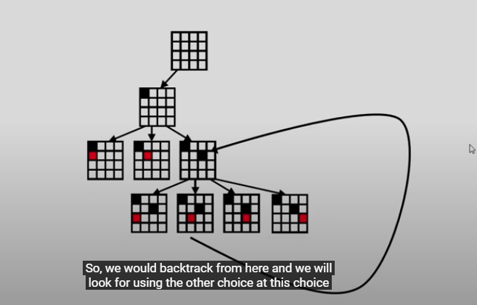

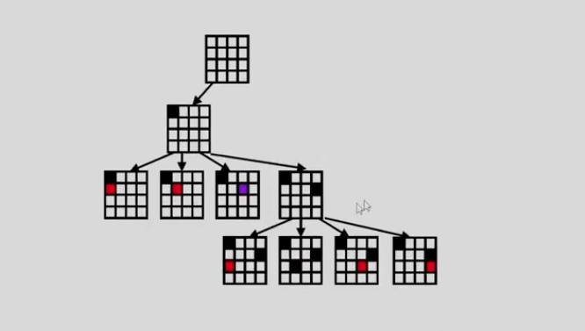

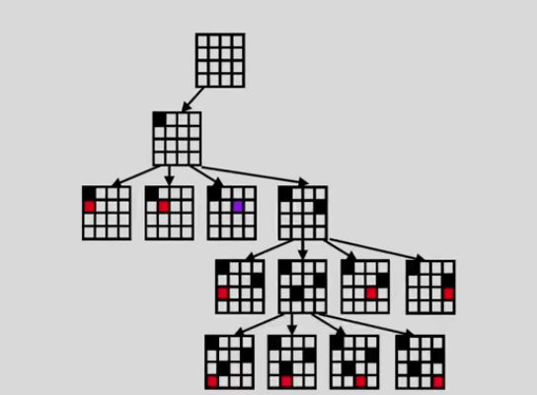

Backtracking to last choice point that is not yet exhausted.

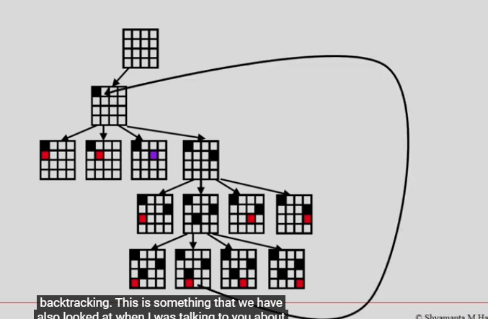

### Backjumping

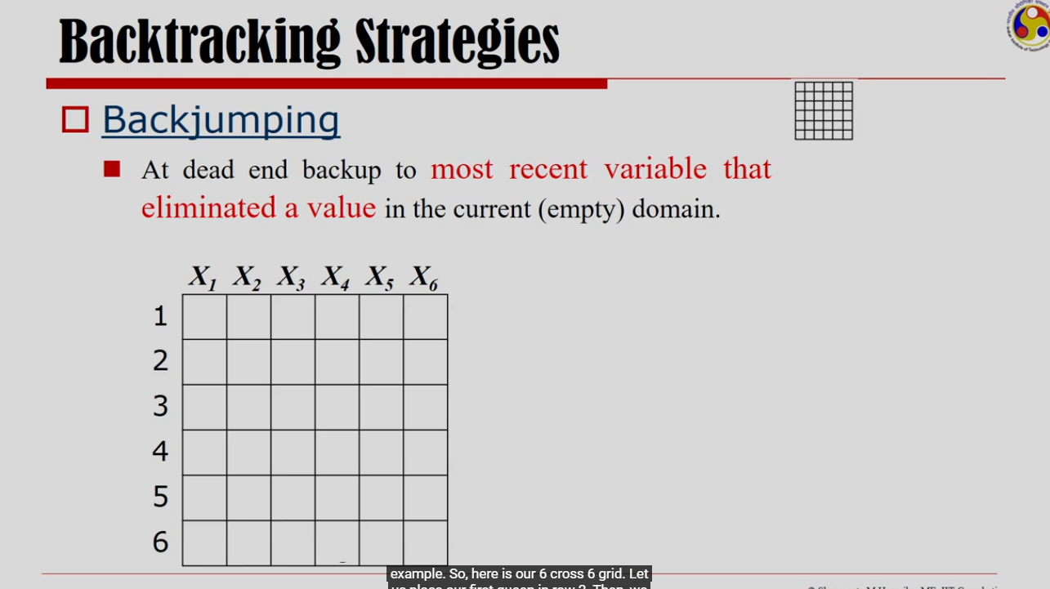

For 6th queen, I can’t use any row. So, I do not have a legal assignment for 6th queen.

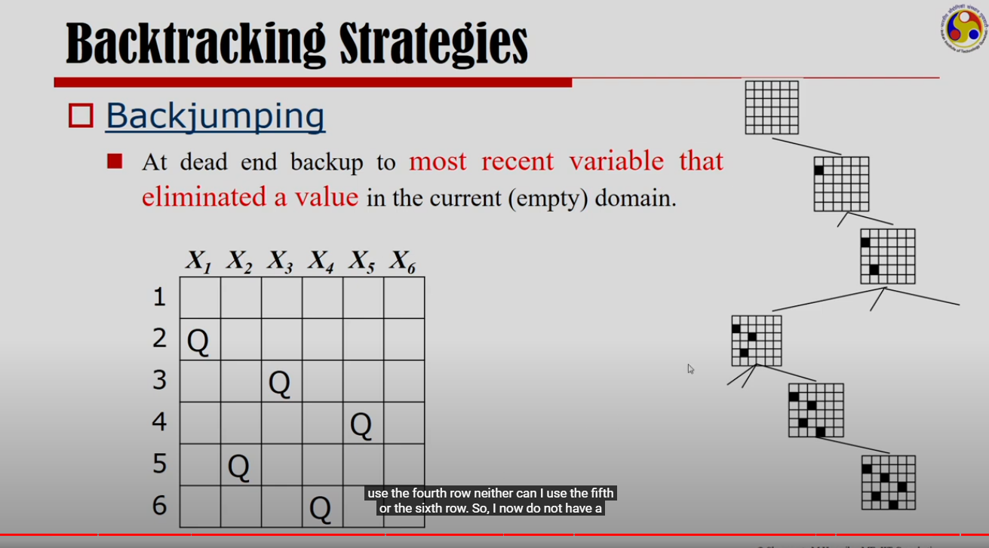

Following shows conflict with 6th queen from other queens.

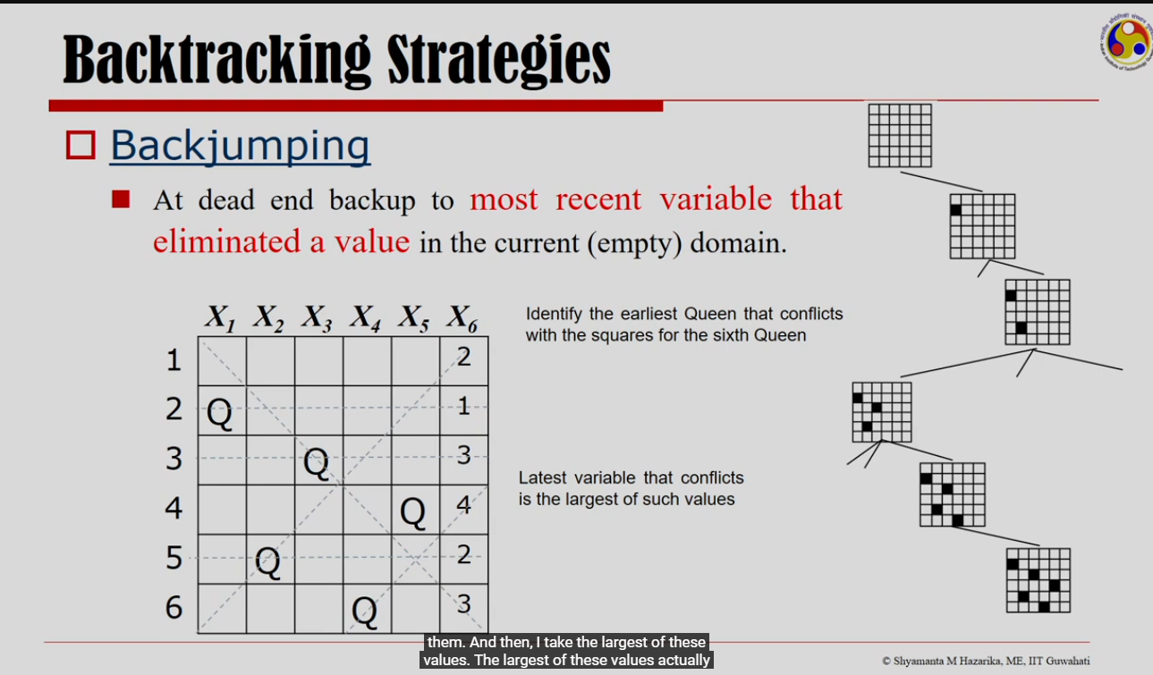

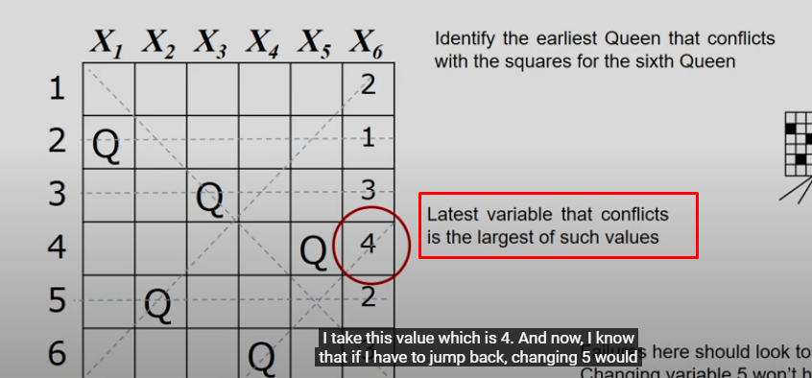

So, I have to make changes to 4th queen.

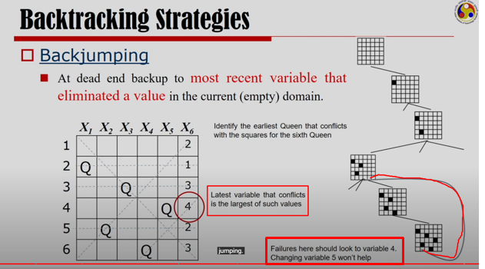

After backjumping, if conflict still arises, then after that proceed with chronological backtracking.

### Conflict-Directed Backjumping

Couldn’t understand as there is no example of it in the video.

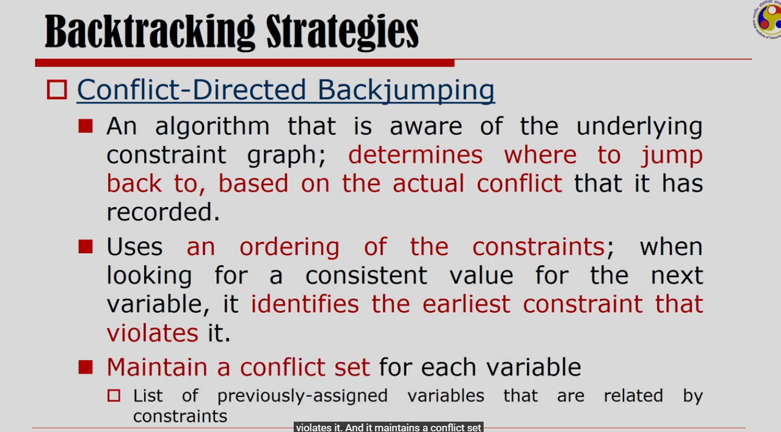

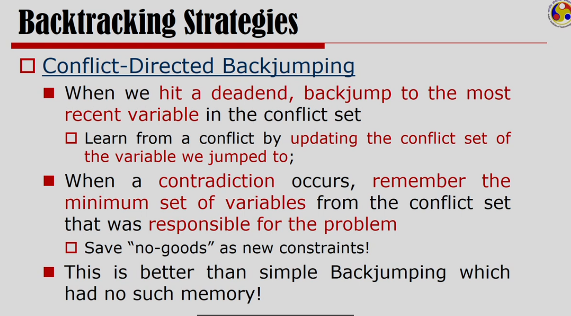

## Summary

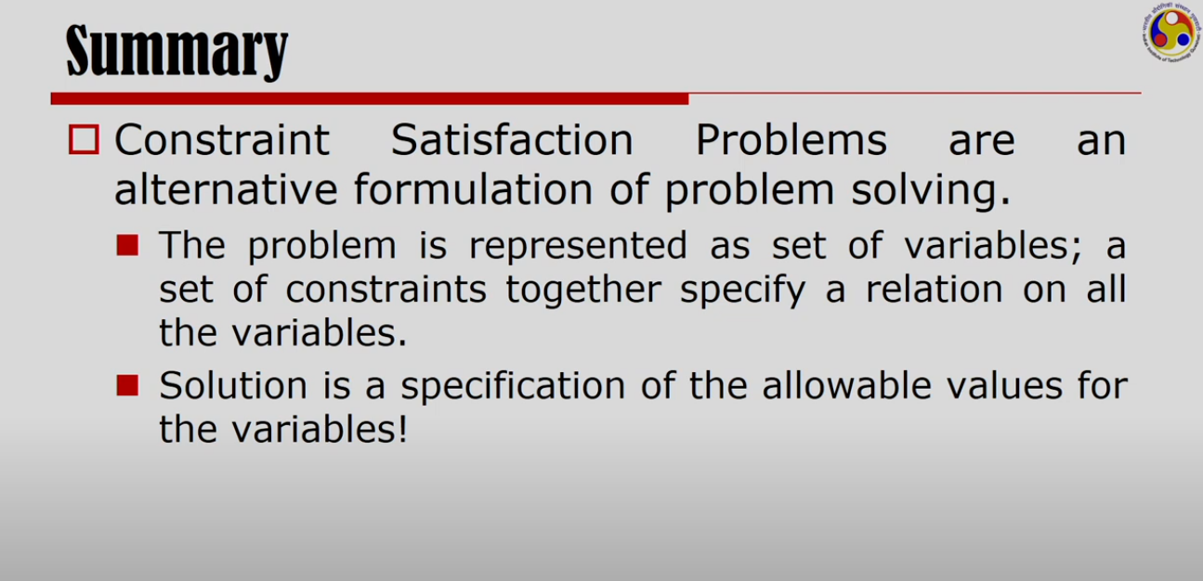

# Searching And/Or Graphs (AO* algorithm)

And/Or graphs problems can be decomposed into smaller problems. To solve an original problem, all these smaller problems need to be solved.

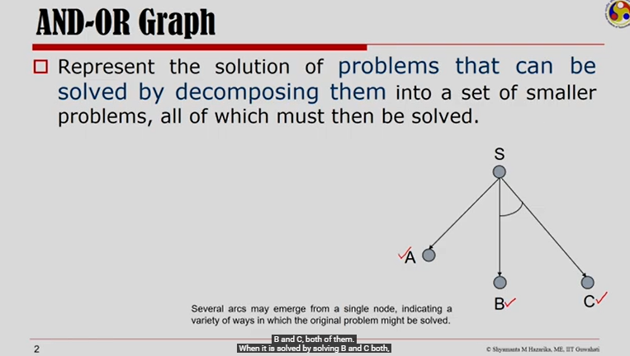

Problem S can be solved either by solving A or by solving both B and C.

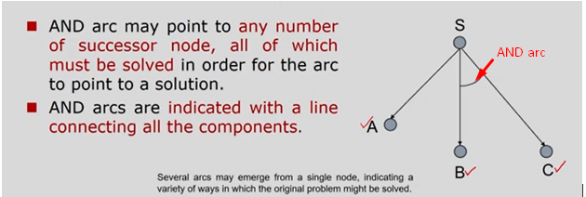

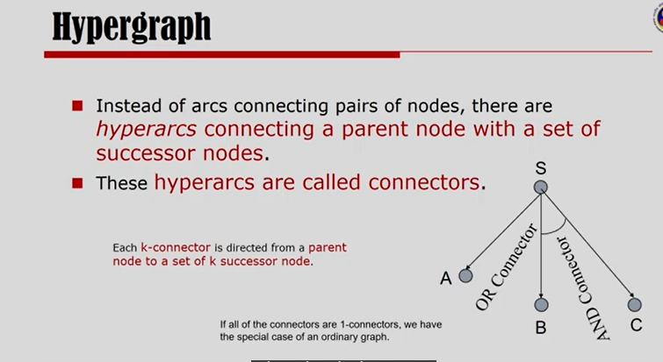

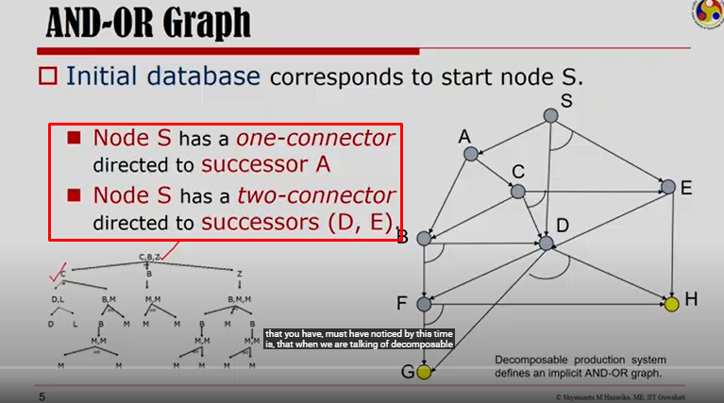

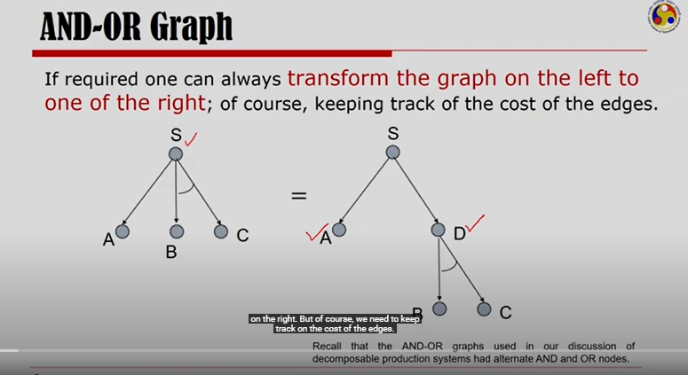

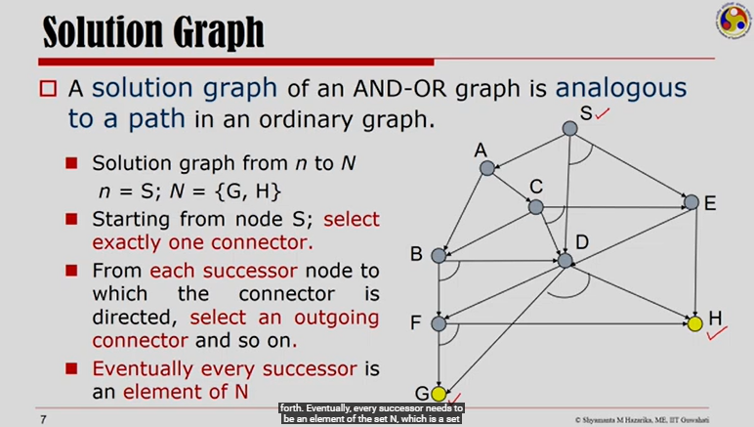

Let’s solve the graph that starts with S and ends at {G, H}

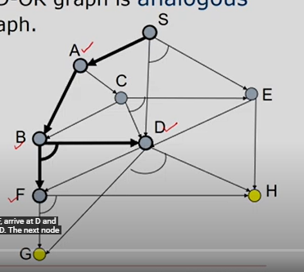

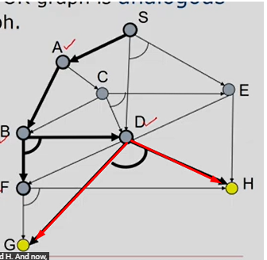

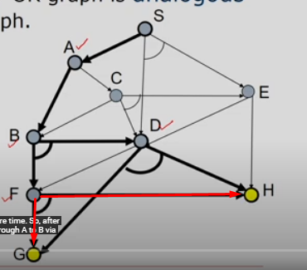

Solution graph looks like as follows.

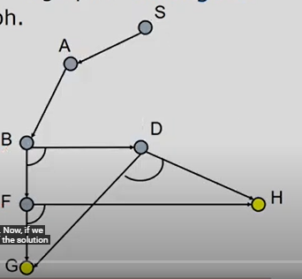

Once G and H are solved, D will be solved.

Once G and H are solved, F will be solved.

Once D and F are solved, B will be solved.

Once B is solved, A will be solved.

Once A is solved, S will be solved.

Alternate solution graph:

Now, instead of going from S to A, we can go from S to D and E.

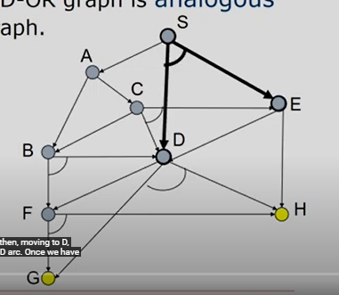

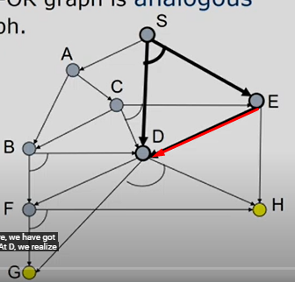

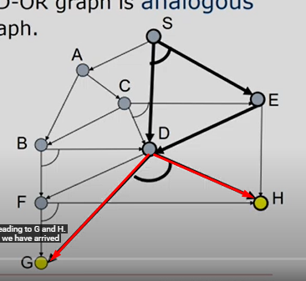

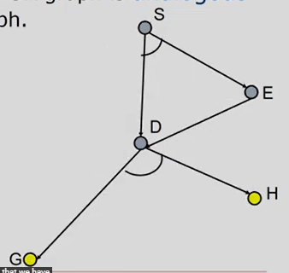

Once G and H are solved, D will be solved.

Once D is solved, E will be solved.

Once D and E are solved, S will be solved.

How to opt for the most optimal solution graph?

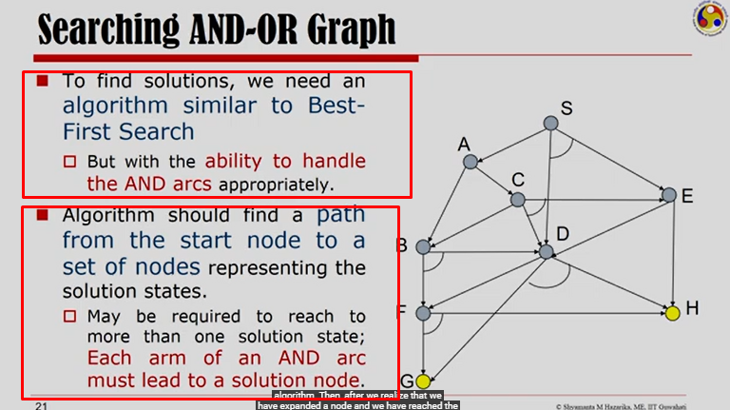

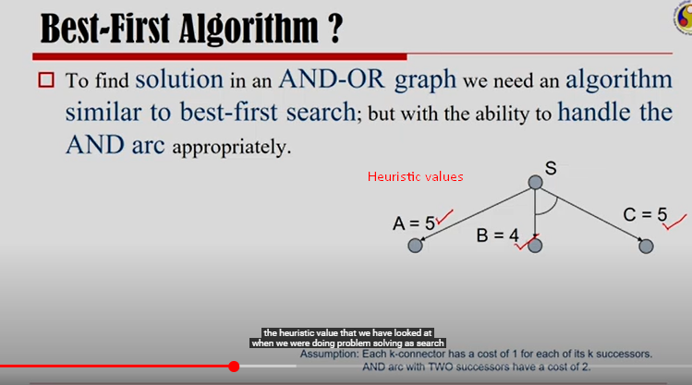

Here we are assuming that edge cost (g(n) is 1 unit. H(n) is the given heuristic value.

Best-First Algorithm formula: F(n)=g(n)+h(n)

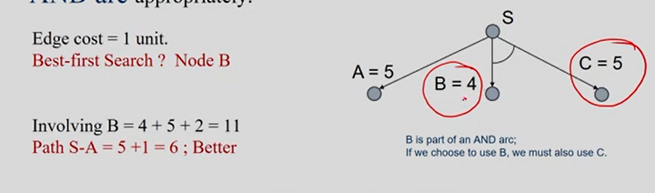

According to Best-First Search, we will select the path going from S to B. But B and C are connected via AND-arc. Total cost will be 4+5+1 edge unit + 1 edge unit = 11

Path S to A is better. Total cost will be 5+1 edge unit = 6

Now, let’s expand the graph even more.

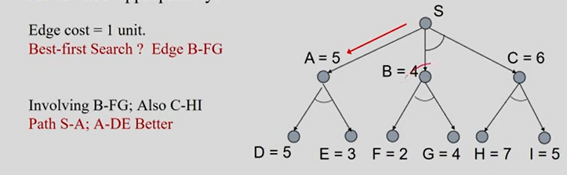

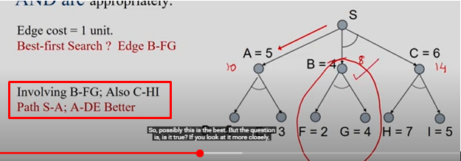

Here, we saw the limitation of Best-First Search is to consider AND arc.

## AO* Algorithm

<https://www.youtube.com/watch?v=u_TE42-uWD0>

Both A* and AO* are based on Best-First Search. Both requires heuristic values.

A* gives optimal solution if h(n) is underestimated.

AO* algorithm is also optimal. It's an efficient algorithm that finds the shortest path between a starting point and a goal by evaluating the cost of each possible path.

### Top-Down graph growing operation AND

### Bottom-Up, cost revisiting, connector-marking, solve-labelling Operation

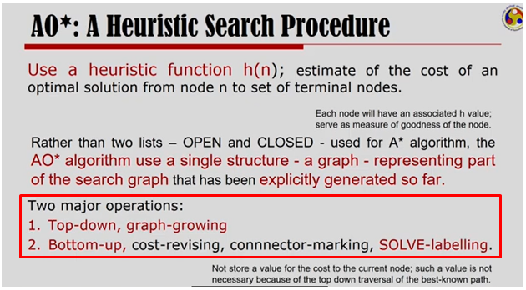

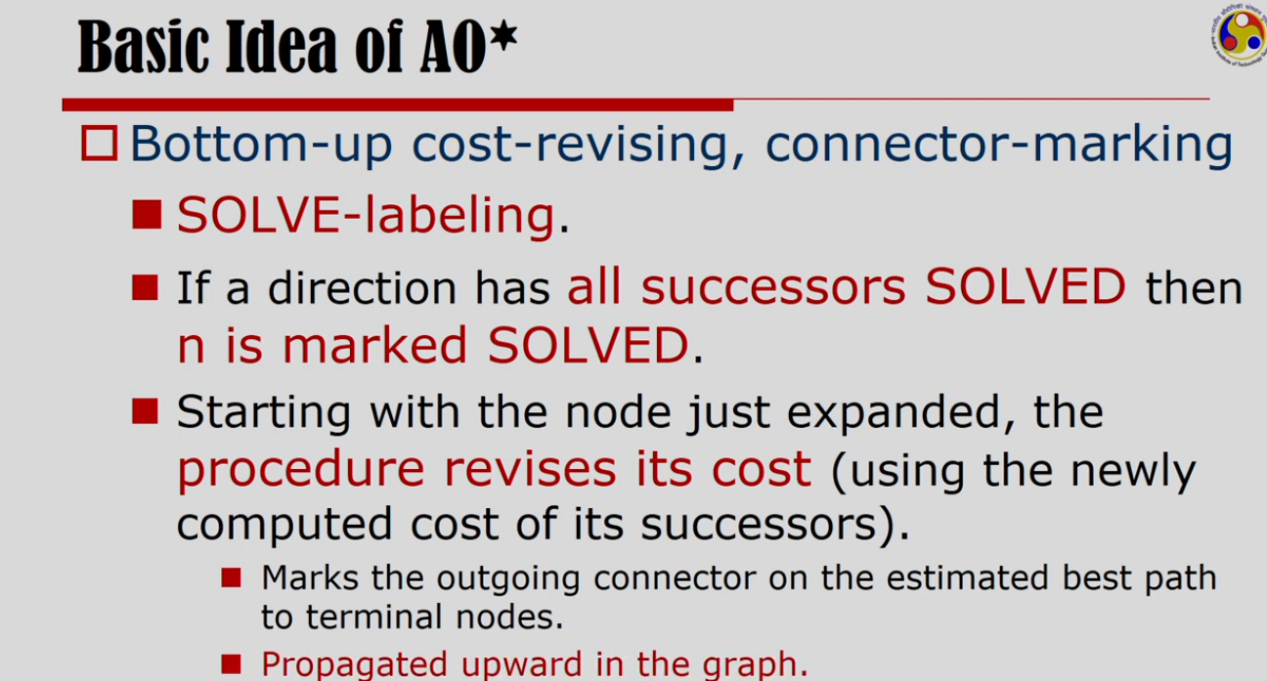

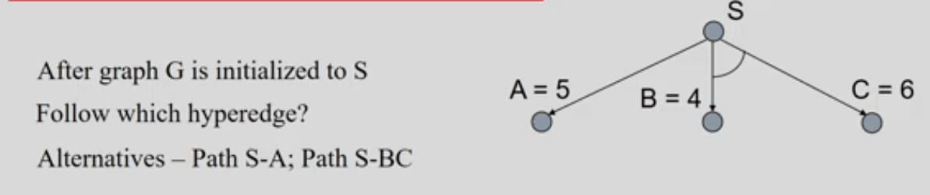

In above graph, let’s assume that the cost of an edge is 1.

For both these alternatives, let’s revise the heuristic values of each node.

If we take the path S->A, cost from S will be 5+1=6

If we take the path S->BC, cost from S will be 4+6+1+1=12

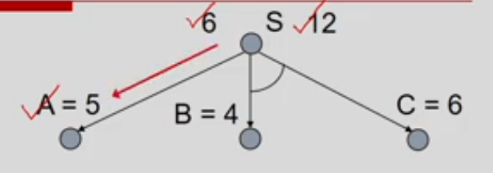

Given these two values 6 and 12, we follow the path S->A

Now, let’s expand A and revisit the costs of A and S. It will become 12 and 13 respectively.

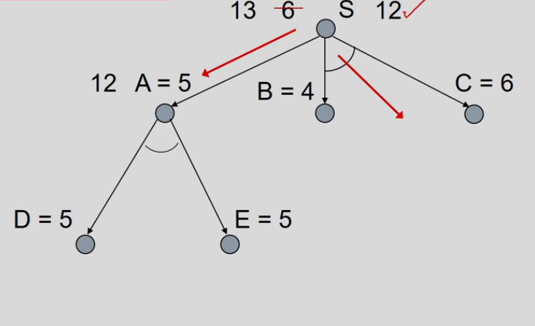

So, S->A path is no longer promising for us. S->BC looks more promising now.

Let’s expand node C now and revisit the costs at C and S. New costs are 12 and 18 respectively.

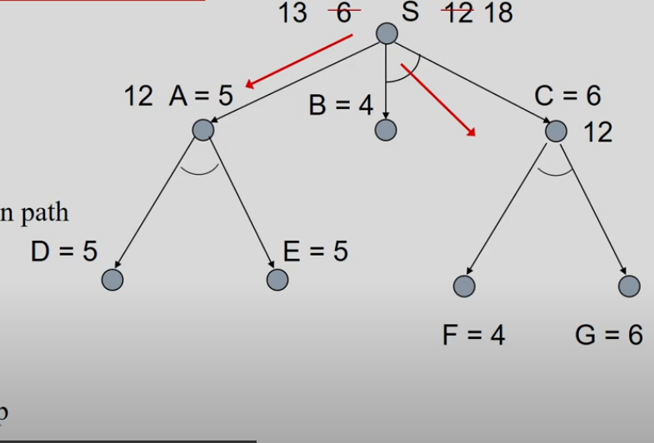

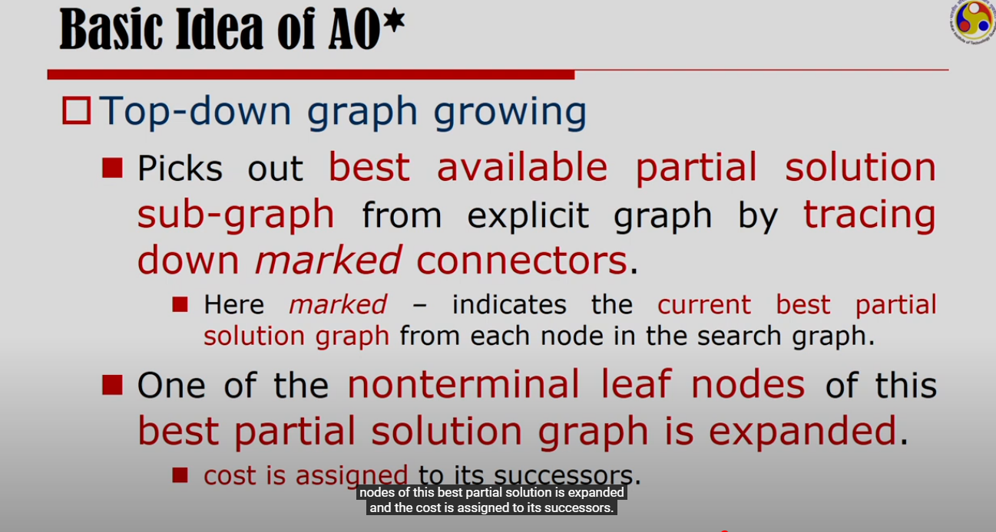

Let’s expand E

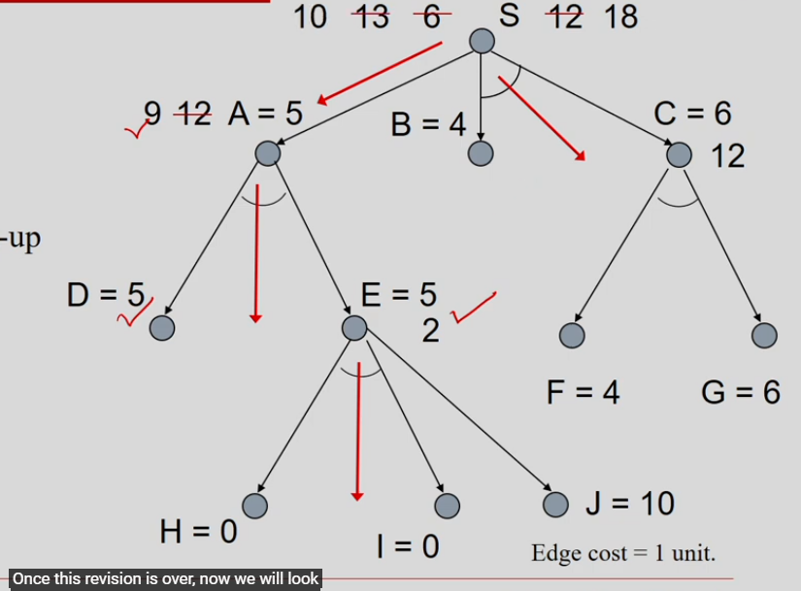

As we reached to the nodes that gives solution (H,I - 0 cost), we will start labelling solved nodes.

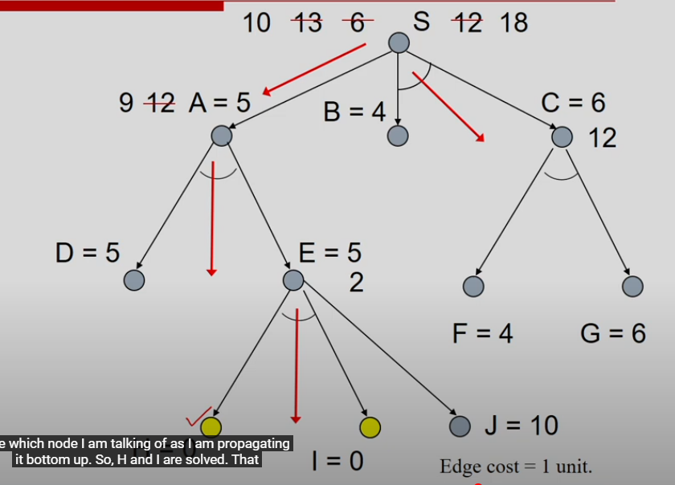

Assume that subtree under D is solved. So, I can mark D as solved.

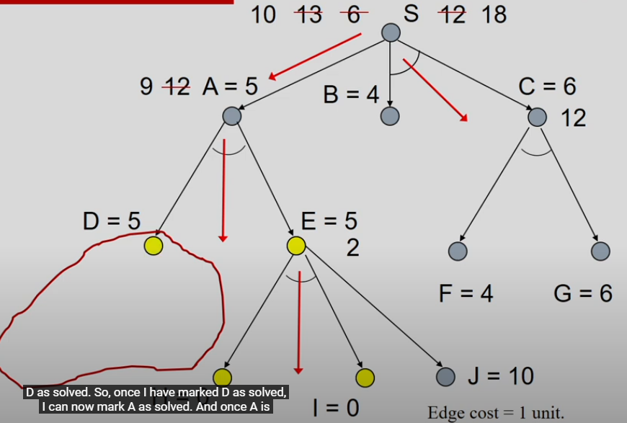

As D and E are solved, I can mark A as solved.

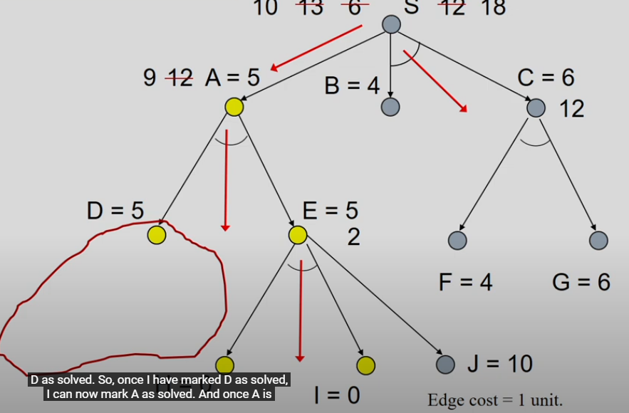

As A is solved, I can mark S as solved.

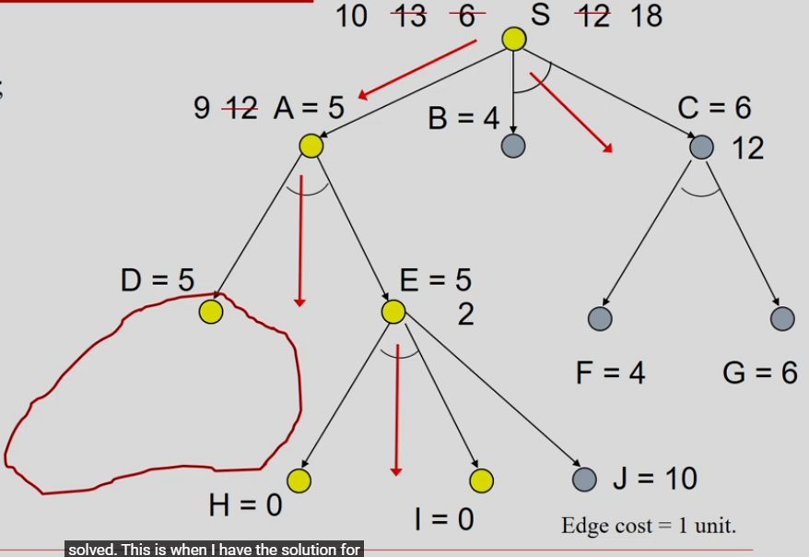

### AO* algorithm pseudo code

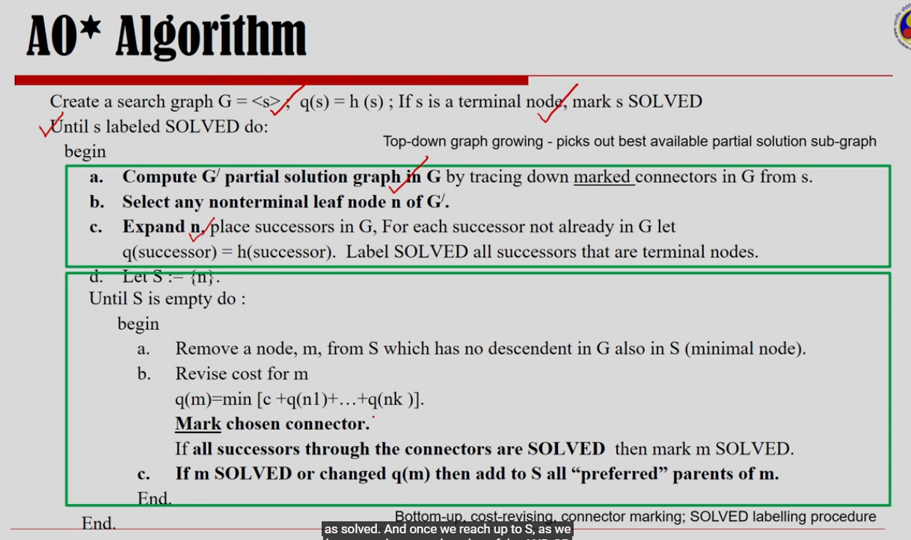

### Applying AO* in our graph

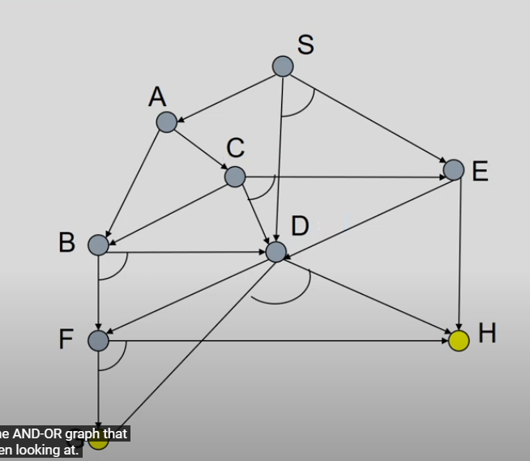

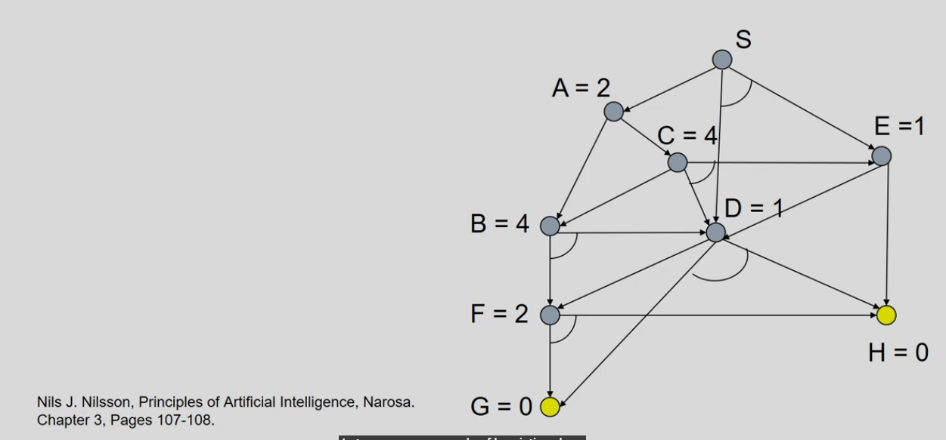

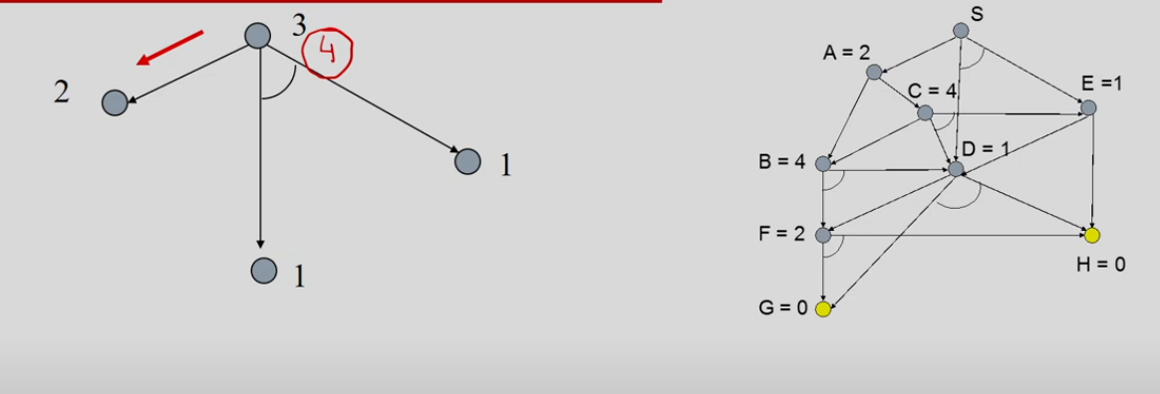

We will take the path S->A

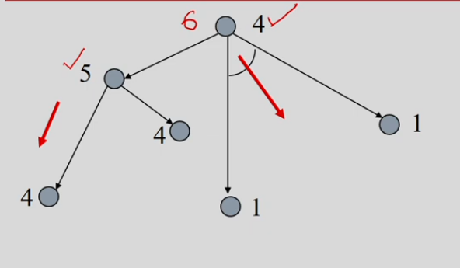

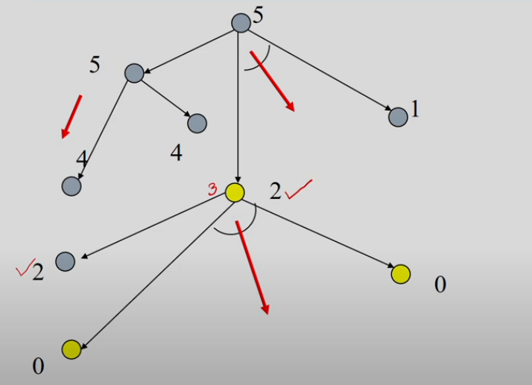

Now, start labelling solved nodes. As G and H are solved, D is also solved.

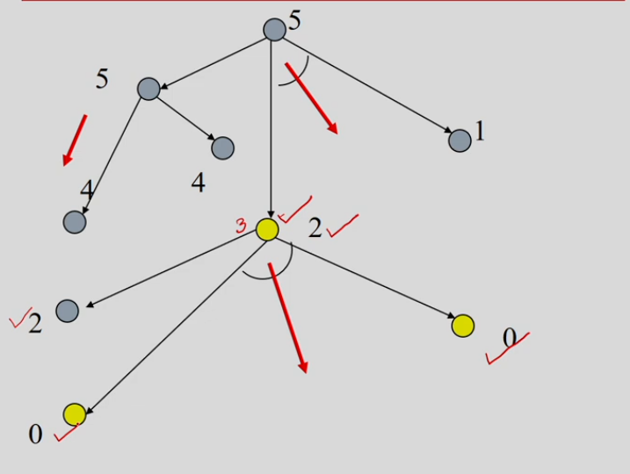

To solve S, we still have to solve E.

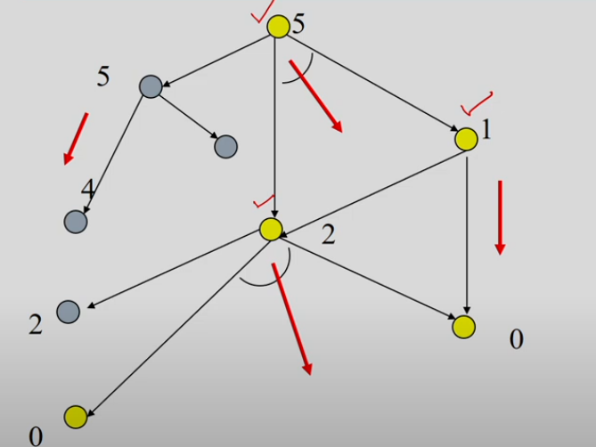

### AO* Modifications

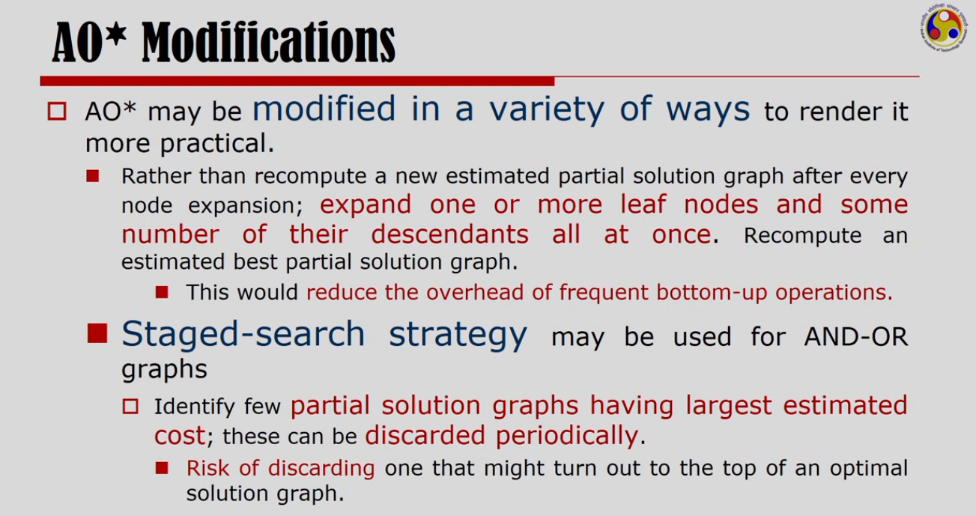

# Game Playing

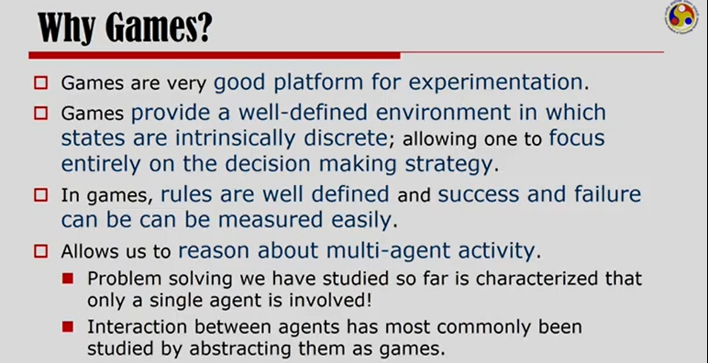

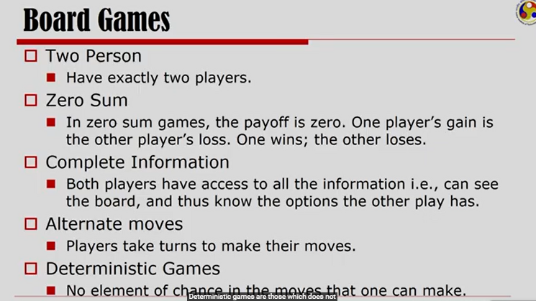

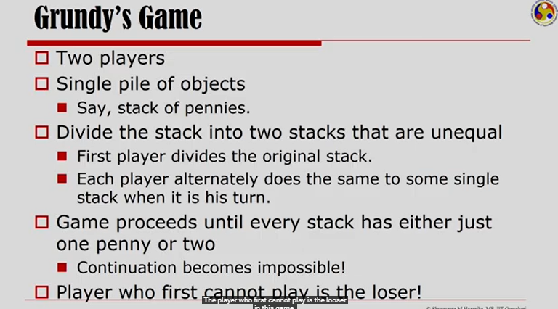

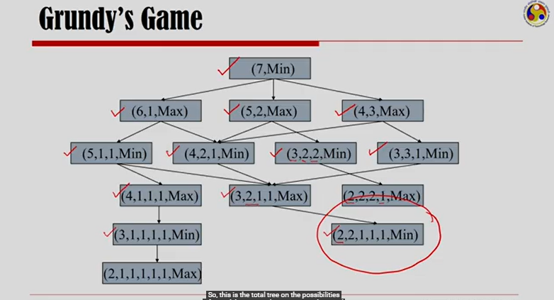

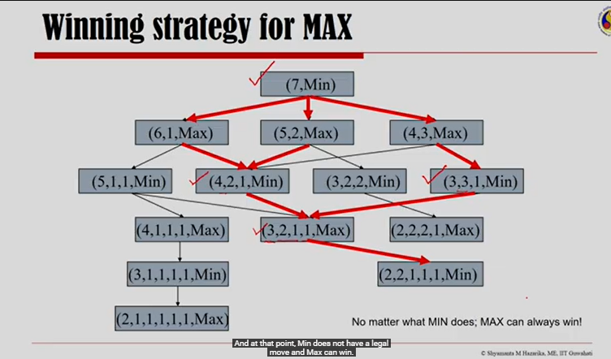

No matter what MIN does in this game, MAX can always ensure that he wins this game.

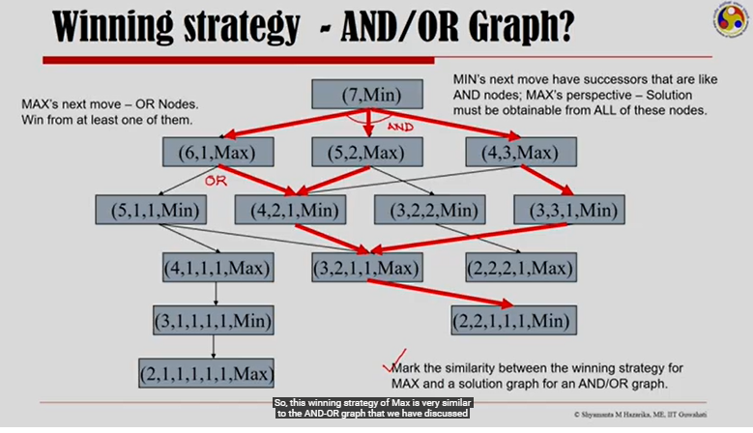

If MIN wants to win, he has to win all three successors. If MAX wants to win, he has to win either of its successors.

Can we apply AO* algorithm here?

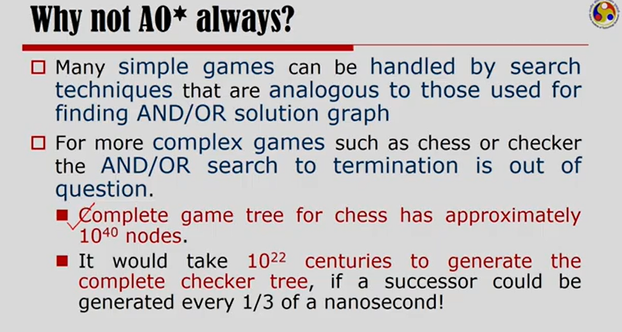

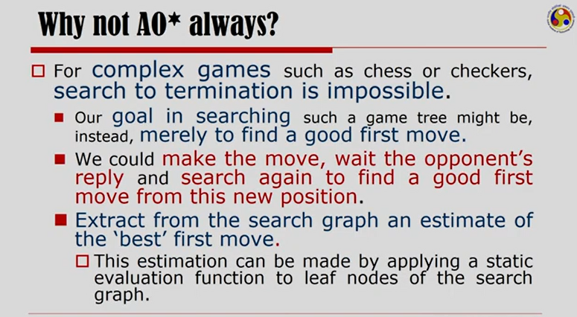

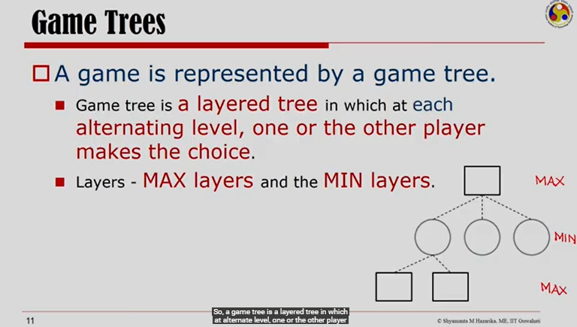

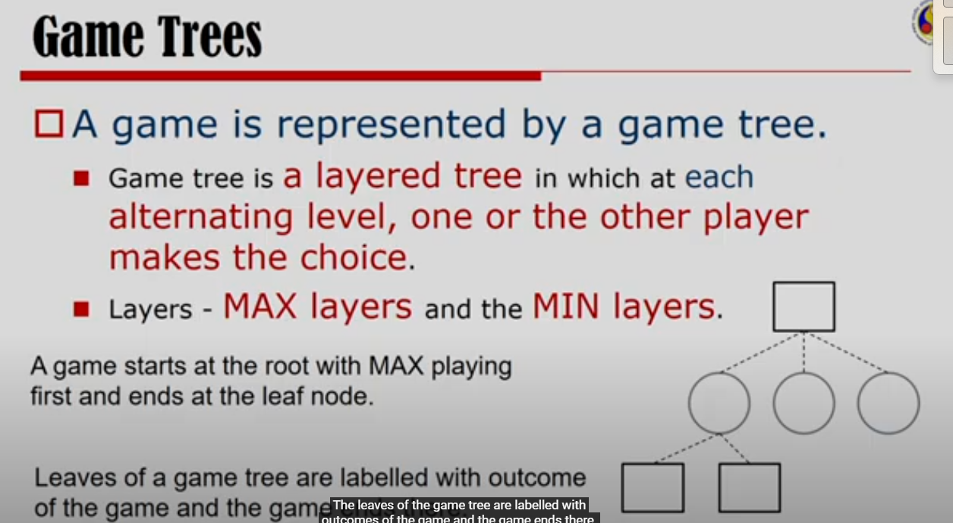

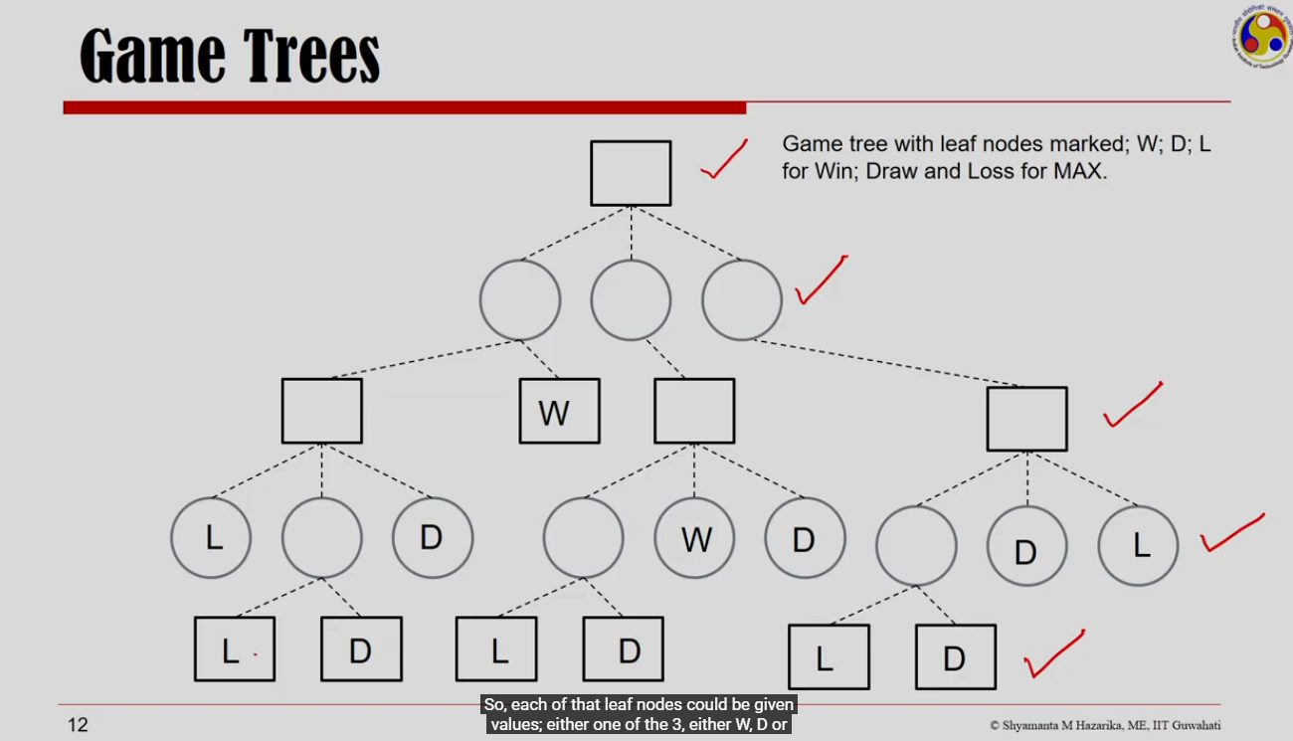

Leaf nodes decides who wins, who looses or it’s a draw.

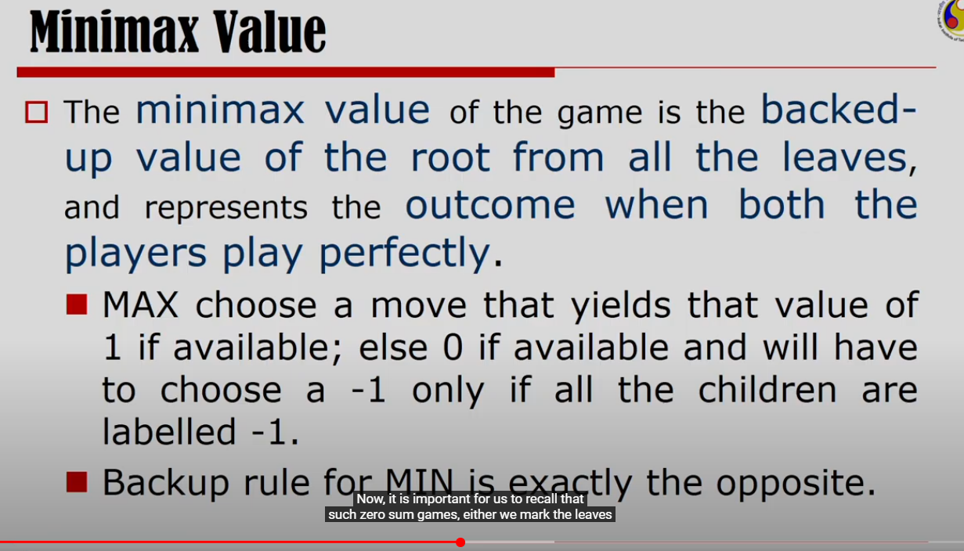

1=win, 0=draw, -1=loss

When MAX wants to make the move, his idea would be to get 1, if available, else 0. MAX will choose -1, if all the children are labelled -1.

